Heart Disease

Analysis of a Silent Killer



Wiley Jones

Computer Science

CS 432

Introduction to Applied Machine Learning

Table of  
Contents

Introduction 1

Questions 4

Data Gathering 5

Heart Disease Dataset 5

Heart Failure Prediction Dataset 12

CLUSTERING AND PCA 19

KMeans without PCA 19

KMeans with PCA 29

Agglomerative Hierachical Clustering 40

REGRESSION 43

Linear Regression 42

Logistical Regression 49

Decision Tree Classification 55

Quantitative 56

Qualitative 62

naïve BAYES 67

Gaussian 68

Categorical 71

Support Vector Machines 75

Polynomial 76

RBF 79

Sigmoid 81

Ensemble Classification 84

Random Forest 85

AdaBoost 91

Stacking 95

Conclusions 97

About the Author and Improvements 101

# Introduction

## Topic Information

A morbid question to ask is what the leading cause of death in the United States is. Despite what the news would make you believe, it has nothing to do with violence, crime, viruses, or infections. Some might think it is cancer, sure to be high on the list. However, the number one leading cause of death for Americans is heart disease. The heart is the most essential organ of all to understand. It acts as a pump to move blood through the body, keeping us all alive; yet many Americans and people around the world seem to neglect the health of this vital organ. It is not difficult to grasp the importance of this topic, but if true insights into the causes of this disease are not explored, lifesaving measures may go undiscovered. That is why this paper is an exploration of the lifestyle and health factors that contribute to and cause heart disease in all its forms. Finding the characteristics that lower a person’s chance of heart disease could mean saving potentially millions of people’s lives.

Research into heart disease is extensive, and it is impossible to provide an overview of all of it. However, a simple introduction to what is meant by heart disease is needed. The classic manifestation of heart disease is a heart attack, where the arteries that supply blood to the heart muscle narrow or shut, leading to an acute (sudden) lack of blood and oxygen to the brain and other parts of the body. Heart attacks can be dangerous and common, but there are many different conditions of heart disease beyond them, including coronary artery disease, heart failure, arrhythmias, valve disease, heart defects, and many more. All have a similar effect on the span and quality of the patient’s life. That is why this paper aims to identify the key factors contributing to the development of these conditions, enabling researchers and everyday people to lead better, healthier lives. In the next section, there will be questions that this report hopes to answer in detail.

Illustration of heart function

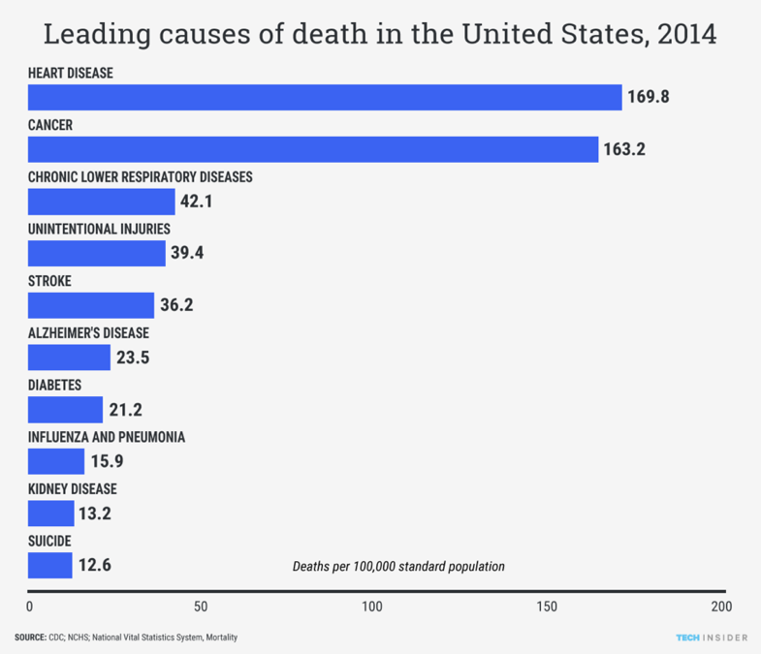Recent advances in machine learning have enabled the analysis of large-scale medical datasets with a level of depth and efficiency that was previously impossible. Algorithms can now detect subtle patterns in patient health records, lifestyle data, and clinical measurements to estimate the risk of developing heart disease. Unlike traditional methods that often rely on linear assumptions, machine learning models can uncover complex, nonlinear relationships between features, offering more nuanced insights. This enables the development of more precise, data-driven risk assessment tools that can enhance both early detection and long-term prevention strategies, moving beyond broad public health guidelines.

Leading Causes of Death 2014

This report utilizes classification models, including logistic regression, decision trees, and support vector machines, to predict the presence of heart disease based on features such as cholesterol levels, resting blood pressure, maximum heart rate, and age. Dimensionality reduction techniques, such as Principal Component Analysis (PCA), are applied to visualize the data in a two-dimensional space, helping to reveal clusters and trends that support interpretation. The focus is not only on achieving high prediction accuracy but also on understanding which features carry the most predictive power. These insights can help healthcare professionals, researchers, and policymakers identify key risk factors and develop more effective interventions.

I chose this topic because I wanted to do something important and had the potential to affect people’s lives, even if it was just my own. Everyone knows someone who has had this disease—maybe even died from it. It is one thing to tell people to have a better diet, exercise, and not smoke, but that doesn’t always engrain into people’s minds. However, having hard data with visualizations, predictions, and recommendations can have a significantly greater impact because it presents the numbers in a way that everyone can understand. I can think of no better topic than heart disease for a report like this one because data science is the perfect method to reveal truths about this disease and present it in a non-technical way for all to enjoy. My goal is that by the end of this paper, readers will have a better understanding of the causes of heart disease, but also, more importantly, tools and recommendations for their own lives to reduce their risk of developing it.

# Questions

* What is the health metric that has the largest connection to developing heart disease?
* What are the biggest lifestyle factors that lead to heart disease, e.g., diet, smoking, exercise?
* Is there a link between BMI and heart disease?
* Do men and women have different factors that lead to heart disease?
* How do different types of chest pain relate to heart disease?
* How does the relationship between cholesterol and blood pressure most align with heart disease cases?
* How does family medical history affect the probability of heart disease?
* What role does stress play in the development of heart disease?
* How does having diabetes affect a person’s chances of developing heart disease?
* What level of exercise is best for reducing the chance of heart disease?

# Data Gathering

## Heart Disease Dataset

This dataset, sourced from Kaggle, is a CSV file containing health and lifestyle metrics for 10,000 individuals with and without heart disease. It is a mix of quantitative and qualitative data. The health metrics, including measurements of factors such as blood pressure and cholesterol, are quantitative data, while lifestyle features, including family history and exercise level, are qualitative data. Interestingly, most of the qualitative data is measured in a Binary fashion, with only ‘yes’ and ‘no’ as the options. However, the dataset also includes a few multiclass classification variables, such as stress level. The label for the data is the “Heart Disease Status” variable, which indicates whether the patient has heart disease or not. This label is valuable because the goal of this paper is to examine the factors contributing to heart disease. Another type of label or one with more options would have to be reworked to fit the objective.

**Quantitative Data Variables**

Age, Blood Pressure, Cholesterol Level, BMI, Sleep Hours, Triglyceride Level, Fasting Blood Sugar, CRP Level, Homocysteine Level

**Qualitative Data Variables**

Gender, Exercise Habits, Smoking, Family Heart Disease, Diabetes, High Blood Pressure, Low HDL, High LDL, Alcohol Consumption, Stress Level, Sugar Consumption, Heart Disease Status

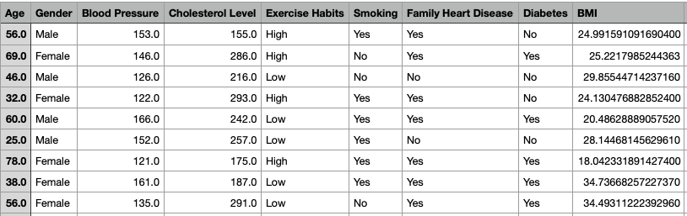

URL: <https://www.kaggle.com/datasets/oktayrdeki/heart-disease>

Data Cleaning

After loading the CSV file into a Pandas data frame, the first step is to verify if any variables in the dataset are not necessary for the analysis. Fortunately, all the variables in this file are useful, so nothing needs to be removed. Here is an image of the initial data frame.   
 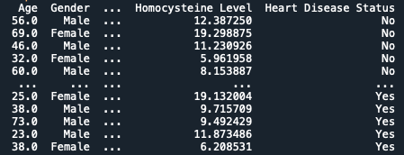

The next step is to determine the number of missing values for each variable. Here is a printout of the results.

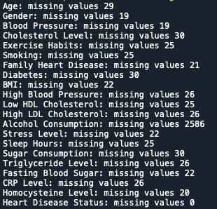

Most columns are missing some values, but the missing numbers are small compared to the total of ten thousand rows of data. However, there is one column that has a significant percentage of missing values—Alcohol consumption at 2586. This is over a quarter of the total entries in the data that are missing this value. This leaves a choice. Should the missing values be replaced, or the rows removed? Although the number is high, all rows with missing values will be excluded from this report. Even after all of them are gone, the data will still have over 7,000 entries, which is more than enough to extract valuable insights. Here is the data after dropping the values.

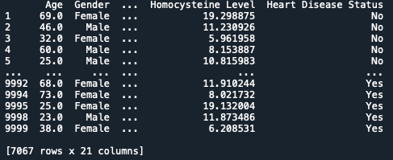

The next step is to check that there are no mistakes or outliers in the data. For the categorical and Boolean columns, this is relatively simple. Since the values in these variables can only be one of a handful of options, it is easy to see when there are mistakes. Here are some of the results.

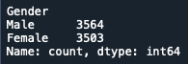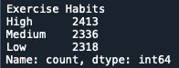  
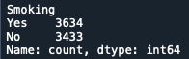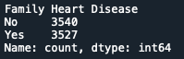

Thankfully, all the categorical variables have the correct values, so no changes are needed there. Once the qualitative variables are checked, it’s time to ensure their data types are switched to category. This data type is best suited for this style of data, which typically has only a limited number of options available. Here is a look at the initial data types.

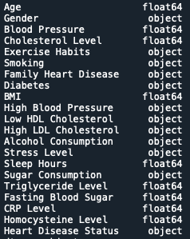

As shown, the qualitative data is all in the object data type, but this is an easy fix since they are all the same. Here are the corrected data types.

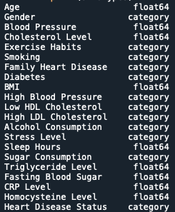

Now that the qualitative data is done, let’s move to the quantitative data. For these variables, visualizations are more effective in identifying any discrepancies in the numbers. Boxplots work well as they allow outliers to jump out of the data rather than be hidden in a sea of rows and columns. Here is an example of one of the plots used to check the data.

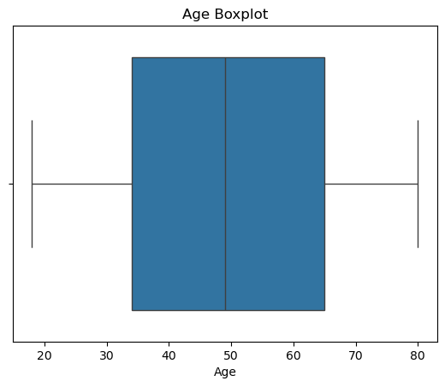

The data has a good distribution throughout the spectrum of values, and none of the values are outliers or mistakes. Here is another way to see this normal and preferred distribution in a density plot.

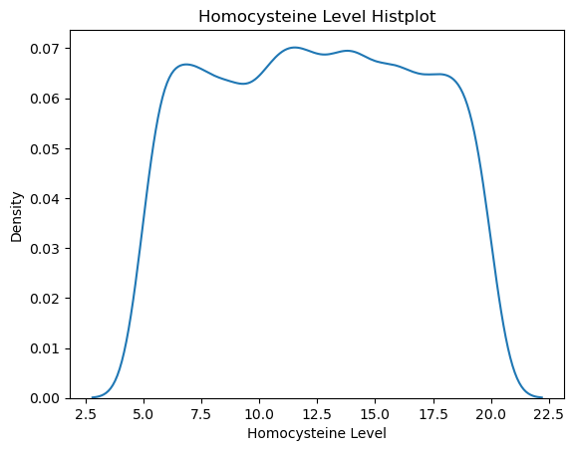

The values are all within a reasonable range, with no impossible values. All the quantitative values are presented in this manner, so no cleaning is required. As a final look at the data, let’s see how this plot works when dividing it by the label.

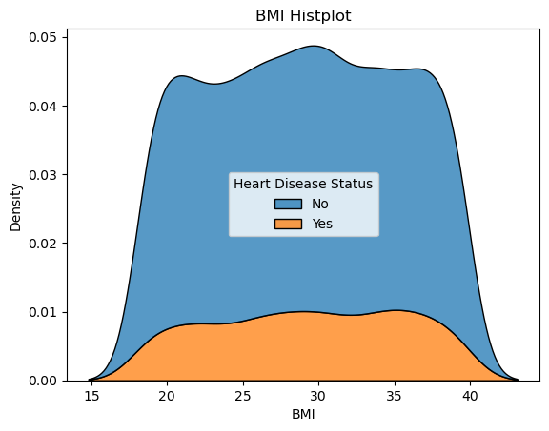

The even distribution of values remains when the label segments the data.

At last, the dataset is ready for analysis. Here is an image of the finalized data frame.

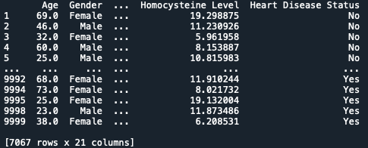

After completion, the data frame is saved back to a CSV file for reuse in other files for analysis. After completion, the data frame is saved back to a CSV file for reuse in other files for analysis.

## HEART FAILURE PREDICTION DATASET

This dataset is also from Kaggle, but it was created by combining publicly available datasets. The five datasets that were used are from Cleveland, Hungary, Switzerland, Long Beach, and Stalog. It is a mix of quantitative and qualitative data, with the label again being whether the patient had heart disease or not. The difference in this dataset is that it includes additional heart-specific measurements, such as chest pain type, resting ECG, and ST Slope. However, most of these variables are qualitative and indicate whether something is outside the normal range rather than providing specific numerical values. Nevertheless, there are still multiple quantitative measurements that can be utilized in quantitative-only models, such as clustering.

**Quantitative Data**

Age, Resting Blood Pressure, Cholesterol, Max Heart Rate, Old Peak

**Qualitative Data**

Sex, Chest Pain Type, Fasting Blood Sugar, Resting ECG, Exercise Angina, ST Slope, Heart Disease

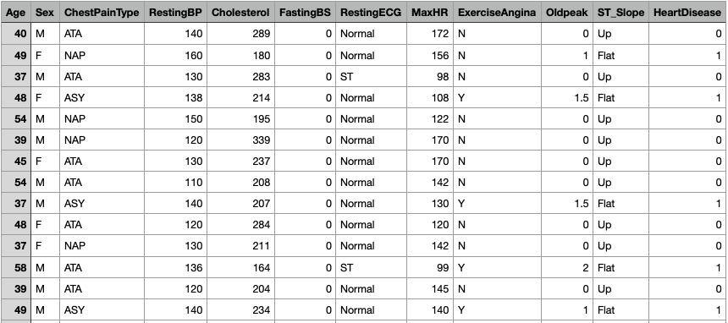

URL: <https://www.kaggle.com/datasets/fedesoriano/heart-failure-prediction/data>

Data Cleaning

The first order of business is to check that there are no columns to remove from the dataset. All the variables are usable for analysis in this data, so they will be kept. Here is a printout of the initial data frame.

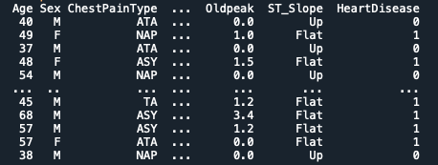

This time, let’s verify the data types to ensure they are correct.

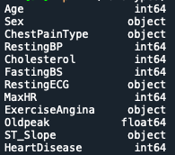

Here again, the qualitative variables must have their datatypes changed to category type. Additionally, the heart disease and fasting blood sugar variables can also be categorized. They are being read as integers, but their actual values are 0 for ‘no’ and 1 for ‘yes’. Therefore, they are categorical. The results of these changes are below.

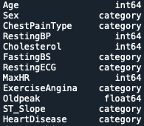

The other data types are fine to keep, as the remaining columns contain quantitative data that must be numerical. Now, it’s time to check the missing values in the dataset.

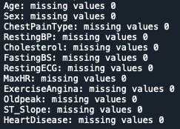

As shown, there are no missing values from this check. This outcome doesn’t mean that there isn’t anything missing. It simply means that none of the cells are null. There may still be missing values that contain placeholders. Now let’s check that the qualitative variables don’t have any mistakes. Here are some of the results.

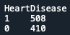 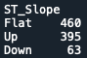 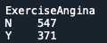

Luckily again, all the categorical data has the correct values with no outliers or typos causing problems. Therefore, there’s nothing that needs to change on these to prepare for analysis. Lastly, let’s confirm that quantitative data is also in good order before moving on to the models and analysis. Here we start to see that there are some issues.

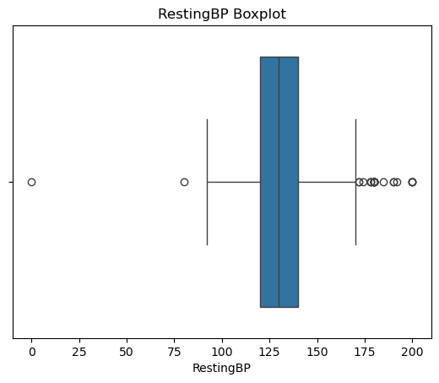

This boxplot of Resting Blood Pressure shows a value of 0, which is impossible for a living person. We will remove that value from the data. Examining the next variable, Cholesterol, reveals an even more significant issue.

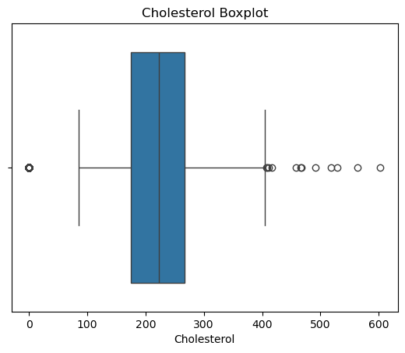

This may appear similar to the previous plot, where only one person had a resting blood pressure of zero. However, the cholesterol value count table shows 172 rows with a cholesterol value of zero.

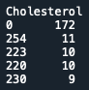

This represents a significant portion of the data that requires attention. Since Cholesterol is an important health metric in understanding heart disease, these zero values can’t be replaced with the average of the other cholesterol values because that might skew the results. Therefore, these values will also need to be removed. This decision requires a substantial amount of data, but modifying the Cholesterol variable seemed too risky, as it could introduce error or bias into the data.

Lastly, the graph for Oldpeak appeared off because it included negative values. Oldpeak is the measurement of ST depression of an ECG during exercise compared to when the person is at rest. An Oldpeak reading of around zero is expected for a healthy heart. This means that there is no change in blood flow when exercising. A positive old peak indicates that the heart is not receiving enough oxygen during stress, a sign of potential heart disease and failure.

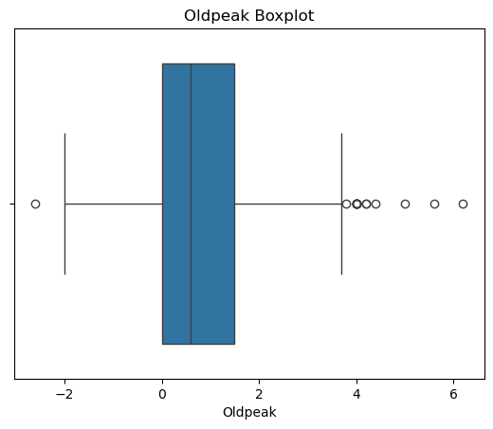

However, the negative values seemed to be present. Still, after research, it was revealed that negative values are possible but are much rarer and usually caused by other factors that don’t relate to heart failure in the same way that positive values do. Therefore, the Oldpeak variable does not need any cleaning in the end.

After all of that, the dataset is cleaned and ready for processing. Here is an image of the finalized data frame.

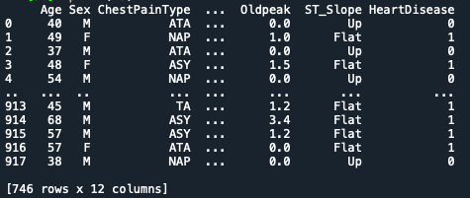

Finally, the data frame is read back into a CSV file for later use.

# CLUSTERING AND PCA

## KMEANS without PCA

The Heart Disease dataset will be used for this project's K-Means analysis. Here is a refresher image of the cleaned data.

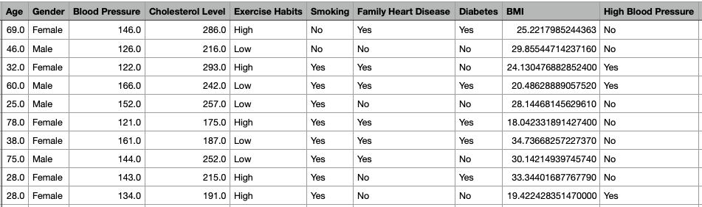

First, the Label for the dataset is removed and saved for later use. Next, this dataset contains many categorical features that require attention. While we could one-hot or ordinal encode many of the categorical variables, some experimentation has found that they muddle the data too much and lack insights. The K-Means algorithm with these features is too distorted by the binary and ternary columns, resulting in almost nonexistent clusters. Because of this, only the variables that are numbers in the initial dataset will be used. Here they are below.

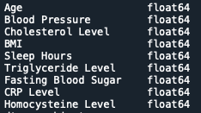

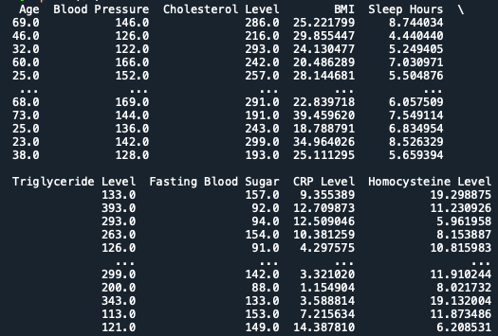

All the columns are quantitative; however, since some of the variables are on different scales, they must be normalized to ensure there is no bias in the results. For example, Cholesterol Levels are in the low two hundreds or high one hundreds, but sleep hours are never over ten. Normalization will preserve the relative differences in the values, while their absolute values compared to other variables will remain constant.

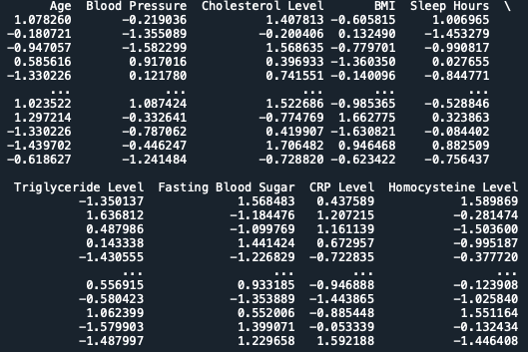

The dataset is now ready for K-Means analysis. However, what is the best number of clusters to use? For this project, three different values of K will be used. The first is a two-cluster model, as the label for the dataset is binary, distinguishing between heart disease and no heart disease. The other two will be decided using the elbow and silhouette methods.

The Elbow method is applied to the dataset using 1 to 10 clusters. The inertia (within-cluster sum of squares) is calculated for each value of K. This measures how tightly the datapoints are grouped. Lower values indicate tighter clusters, resulting in less variance within each cluster. Plotting the trend of Ks and inertia, the point at which the decrease in inertia starts to slow down significantly is called the elbow point. This is the ideal number of clusters.

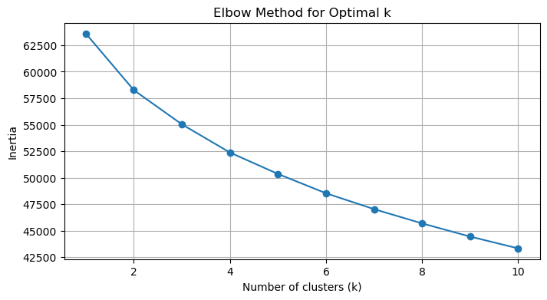

From the results of the Elbow method graph above, the largest elbow point is at 2 clusters, which have already been selected. However, no other significant change in inertia could be identified as a possible second candidate. To combat this, here is an expanded graph that shows the number of clusters up to 30 instead of 10.

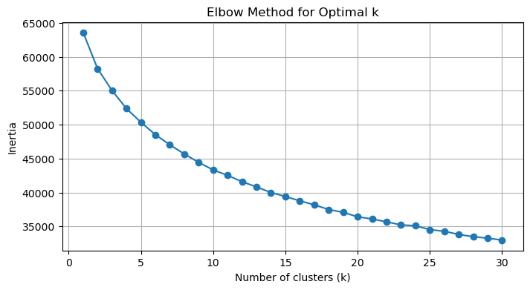

Although there isn’t an apparent elbow, adding in more K values gives a better idea of the trends. From this graph, at 5 clusters, the inertia seems to slow in its descent. Therefore, the second value of K-Means will be five.

Along with the elbow method, there is the silhouette score comparison for choosing K. The silhouette method calculates the silhouette score for each data point within its cluster, comparing it to the scores of the other clusters. If the score is 1, the point fits in its cluster perfectly, 0 means it’s on the border between different clusters, and -1 means that it is probably assigned to the wrong one. After calculating the average of these scores across all data points, the clusters with the highest average silhouette score are identified as the best.

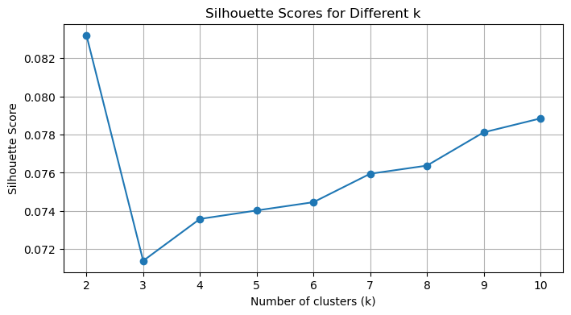

Again, two clusters have the best overall score, as indicated in the chart above. However, ten clusters are not far behind four, so they will also be added to the list. However, the values continue to increase after running the silhouette score with more clusters. This is concerning and appears to be a case of overfitting the data.

Finally, the list of K-Means cluster values is set at two, five, and ten.

Two Clusters

From the outset, the data appeared to be incorrect. All the cluster centers were extremely close together with little separation.

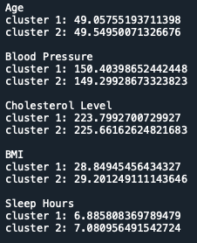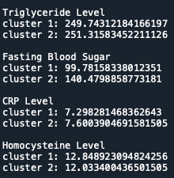

This lack of definition in the clusters typically means that the data lacks any natural clustering, so the K-Means algorithm is unable to handle it effectively. K-Means as a process assumes that the clusters are spherical, but if the data is spread evenly without any real patterns, it will not be able to separate the clusters, leading to a jumble of points that don’t appear clustered.

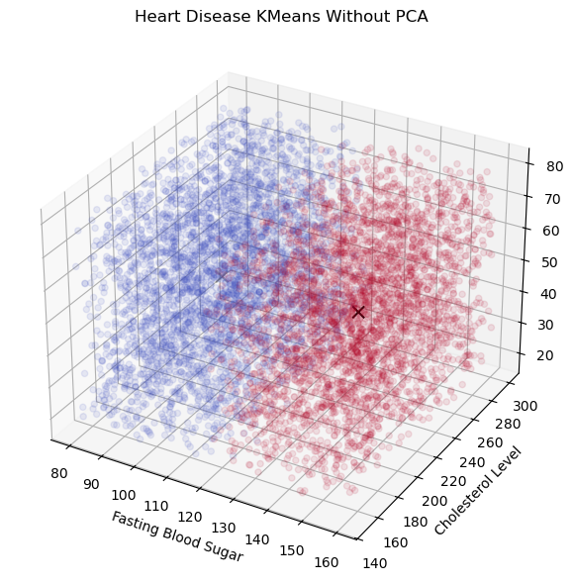

The only variable that showed a significant separation between the two clusters was Fasting Blood Pressure. That was the one feature that allowed K-Means to identify substantial differences to separate the clusters. The graph above separates the clusters perfectly down the fasting blood sugar midpoint, while cholesterol and age do not affect the clusters. This K-Means model splits the data by Fasting Blood Sugar without considering the other variables.

Looking at the elbow and silhouette graphs before, it is not surprising that K-Means is struggling with this dataset. The highest the silhouette score ever achieved was 0.0825—not a particularly good indicator of good clusters. Therefore, the next cluster's numbers will likely be similar to this one, with Fasting Blood Pressure dominating the analysis.

Five Clusters

With five clusters, most of the problems from the two remain, but some features exhibit a slightly more structured pattern. The triglyceride level jumped out this time, as it had more variety in its cluster centers than before.

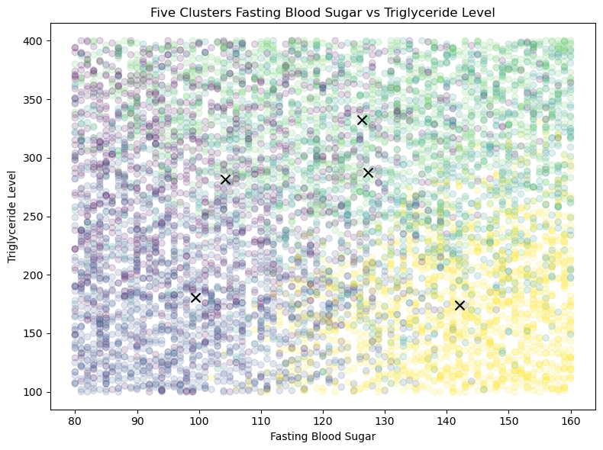

However, even with this improvement, many clusters still don’t make sense or are too close to one another to yield any meaningful insights. For example, the same graph but with different x and y axes shows that there is still randomness in the clusters.

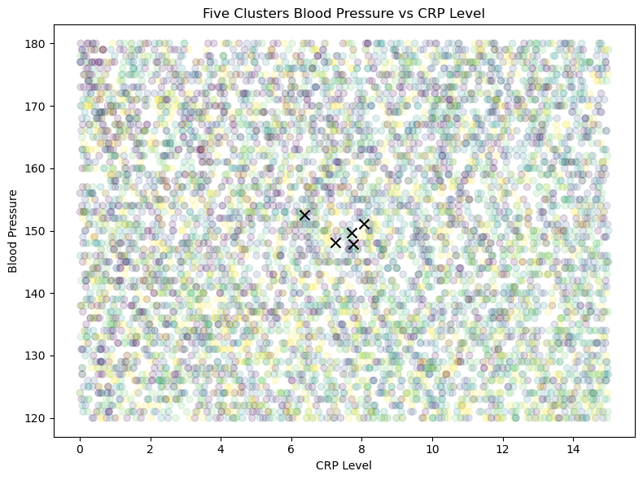

Here, the clusters are scattered throughout the dataset with no discernible structure. This means that K-Means is still having trouble finding clumps in the data it likes because of its uniformity.

Ten Clusters

At ten clusters, an interesting correlation between Age, Fasting Blood Sugar, and BMI starts forming, although it isn’t the clearest pattern.

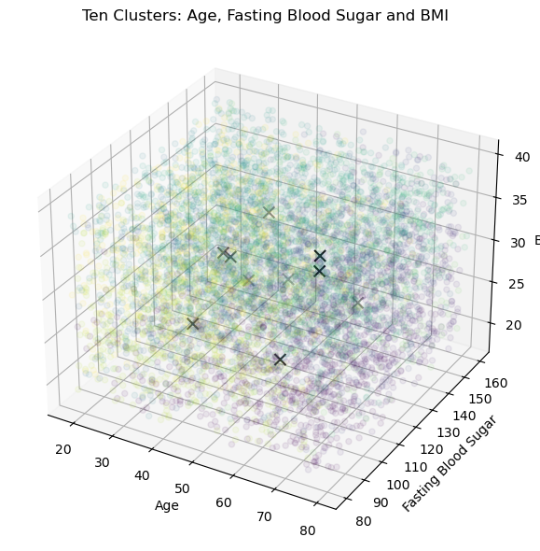

Several recognizable patterns are evident in this chart. For individuals with low BMIs, age is divided between the young and the old. However, as the BMI rises, people, regardless of their age, are grouped in similar categories. This difference may indicate an increased risk of disease for individuals with a larger BMI index, while the lower BMI data points are more evenly distributed by age group because their risk of obesity-related complications is lower.

Results

However, these groups are not perfect, and considerable uncertainty remains about them. Nevertheless, it’s good to see that the K-Means algorithm might have something to reveal about the data.

This K-Means analysis revealed that the dataset lacks true clusters, as no spherical K-Means clusters formed, regardless of the chosen value of K. Even when the clustering created some structure, it was usually weak and not fully reliable. However, this does not mean that no insight was gained from this exercise. In terms of what the most important factors are in the data, K-Means certainly is saying that Fasting Blood Sugar and Age are two of the most important. When there were only two clusters, Fasting Blood Sugar was the feature that most significantly affected the clustering, and it remained a significant part of the clustering going forward. Age emerged later in the analysis but was still found to be a primary factor. Both make sense, as high blood sugar is a sign of diabetes. Diabetes is linked to heart issues, so it’s no surprise that it would jump out of the data. Age is also a significant factor, as heart disease is more prevalent in older generations than in younger ones.

The most surprising aspect of this analysis is that Blood Pressure and Cholesterol were not significant factors and had a minimal impact on the data. Very unexpected, as the common wisdom is that high blood pressure and Cholesterol are telltale signs of heart issues. However, it is possible that the nature of the K-Means algorithm, which focuses on identifying clusters in the data, may not adequately capture the importance of these factors, as they are smooth, continuous values, which K-Means doesn’t handle well. Overall, the makeup of this dataset may not make it the best candidate for use with K-Means. There are too many continuous values to gain insights from them. Nevertheless, there are a few ideas worth considering from it. In addition, PCA analysis might unlock patterns that the normal K-Means couldn’t see.

## KMEANS with PRINCIPAL COMPONENT ANALYSIS

Principal Component Analysis (PCA) is a dimensionality reduction technique that transforms a dataset from its original high-dimensional space to a lower-dimensional one, while retaining as much of the dataset's variance as possible. This helps reduce noise and highlights the main drivers of variation in the data. In this project, the original 9-dimensional dataset will be reduced to its top 3 principal components, effectively compressing it into a 3-dimensional space. PCA achieves this by computing eigenvectors—known as principal components—that are linear combinations of the original features. These components are ordered by the amount of variance they capture, ensuring that the reduced dataset preserves the most significant patterns in the data.

After completing PCA on our dataset, the following becomes our data frame to work with.

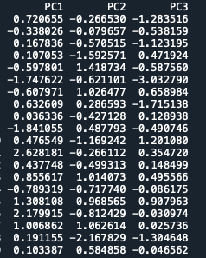

The raw numbers themselves reveal little about the transformed data. For that, the Eigenvectors and values are best. The Eigenvalues of a PCA transformation reveal how much of the variance in the data is explained by each of the descending principal components. If the Eigenvalue is close to 1, then that PC significantly affects the deviations. Since PC’s are computed in descending order of importance, the first PC will always be the most significant driver of variance, decreasing with each successive PC.

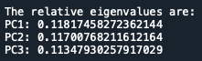

One thing to notice from the Eigenvalues above is that they are all relatively close to one another, meaning that the data is not dominated by one or two PC’s. Also, adding the total number of Eigenvalues together, the three top PC’s only account for ≈34% of the total variance.

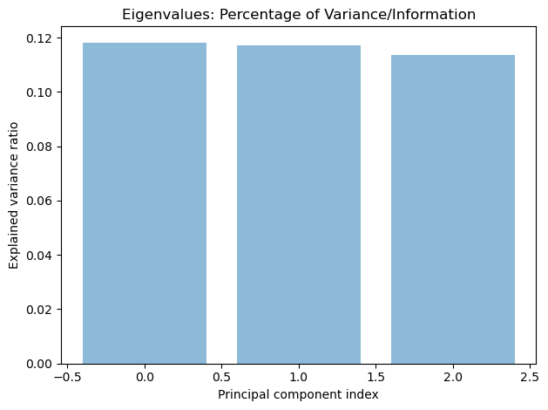

This score isn’t ideal for analysis because it omits most of the information from the data. The hope for most PCA transformations is that the total explained variance is over 70% or 80%. Therefore, the following analysis, which is based only on these three values, cannot be trusted to represent all of the data. Next to check are the Eigen vectors.

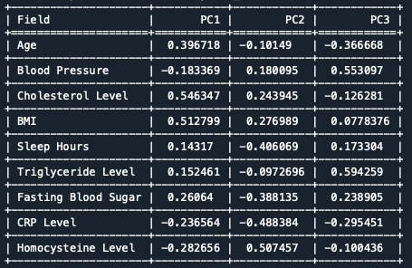

Eigenvectors are the linear combination of the original features that make up the PC’s. Essentially, they demonstrate the contribution of each variable to the PC. A positive value means that a larger value of that factor will shift the datapoint in the positive direction along the PC axis. In contrast, a negative value moves the point towards the negative direction. The sign is not truly important. What is important are the features that contribute most to the component in either direction. Taking PC1 as an example, the largest positive coefficients are Age (.39), Cholesterol (.55), and BMI (.51), while the largest negative coefficients are CRP Level (-.24) and Homocysteine Level (-.28).

From these values, the PCA analysis indicates that older generations with higher BMIs and cholesterol levels exhibit a negative correlation with individuals who have higher CRP and Homocysteine Levels. This relationship could mean that PC1 is a risk profile for lipid-related heart disease, as individuals with high Cholesterol, high BMI, and older age are prone to those kinds of risks more than inflammatory risks such as elevated CRP and Homocysteine.

With the initial discussion of the PCA results out of the way, it is time to move to the K-Means analysis. For the values of K in this analysis, the elbow and silhouette methods will be rerun to determine if any of the recommendations have changed. Two clusters will be kept again, as the Label of the dataset is a binary yes or no.

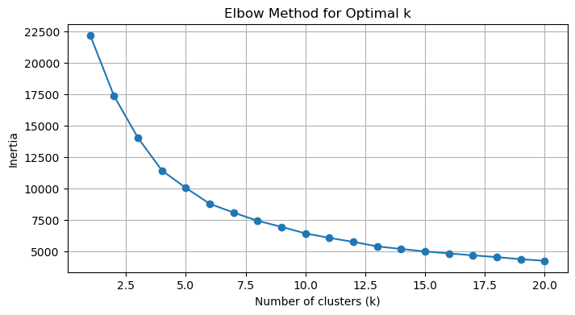

As before, there isn’t a distinct elbow for the data even after the PCA transformation. Nevertheless, the slowdown of inertia is noticeable enough at four clusters, which will be used in this analysis.

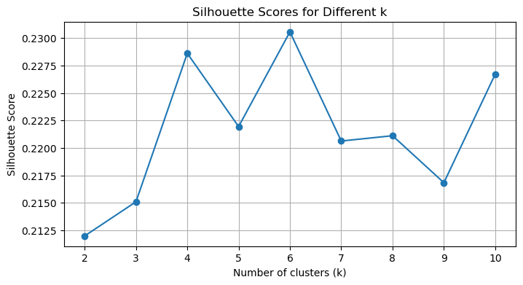

The Silhouette scores also support the choice of four clusters. Along with four clusters will be six with the highest score out of the bunch. However, a silhouette score of .23 for six clusters is not a great sign for the quality of the clustering. Usually, scores need to be .5 or higher to be considered.

Two Clusters

The 2-cluster K-Means produces more structured and consistent results with the reduced dimensionality data from PCA.

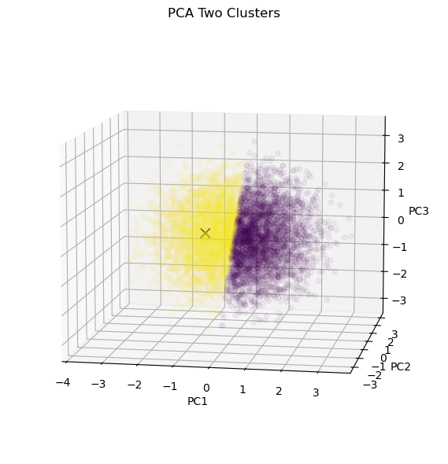

A clear divide in the two clusters cuts almost perfectly down the origin of the PC1 axis. PC1 is the component with the greatest influence over the dataset, so this result is not entirely surprising. As previously discussed, this evidence suggests that the divide between individuals with higher ages, Cholesterol Levels, and BMIs may illustrate a significant risk profile and have a deeper connection to a better understanding of heart disease risk.

Four Clusters

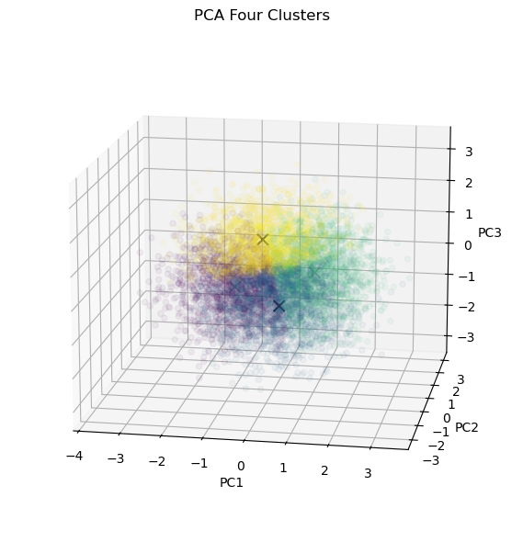

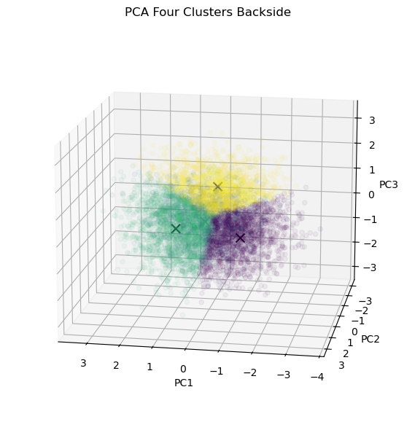

The four K-Means clusters are better than the non-PCA ones, but they still overlap and are unclear. A few patterns are emerging, though. A yellow cluster still dominates the positive values of PC3. Positive PC3 is associated with high blood pressure and high Triglyceride levels but lower ages. This cluster could be another risk profile for young people with hypertension and high lipid counts, possibly due to something like obesity.

Six Clusters

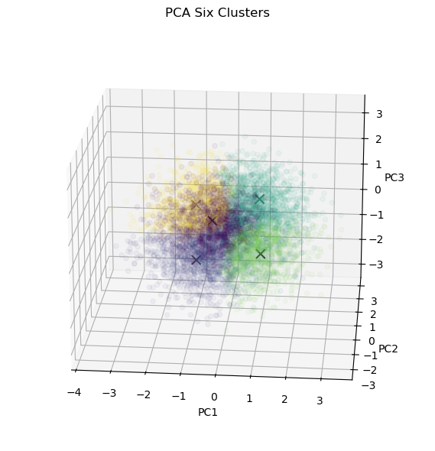

The clusters remain overlapping and lack definition, with six centroids. Yet there are still some features that stand out. In the bottom right-hand corner is a green region that distinguishes itself. This region maps to individuals with high levels of PC1 and low levels of PC2. Looking at the backside graph, the green cluster disappears, meaning it higher PC2 values are excluded from the grouping.

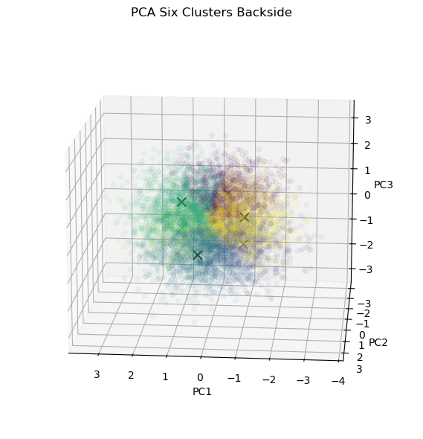

PC2’s main positive feature is Homocysteine Level, with BMI and Cholesterol Level as weaker factors, while its negative features are CRP Level, Fasting Blood Sugar, and Sleep Hours. This means that individuals who land in the green region may have a risk profile for diabetes or pre-diabetes, characterized by higher CRP and fasting blood sugar measures. Adding that to a positive value of PC1—that constitutes higher age, Cholesterol, and BMI—means this cluster could identify a subgroup of extreme-risk patients, as both values of PC1 and PC2 are markers for heart disease.

Results

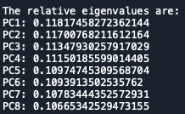The PCA analysis was more fruitful and informative than the non-PCA one. The clusters that emerged were more defined, both visually and logically, based on the data. However, the concern is the relative eigenvalue scores from the beginning. The three PC dimensions accounted for only about 34% of the variance in the data, which is not an excellent measure for extracting usable insights. If the PCA instance is changed so that 80% of the variance must be explained by PC’s, the process results in eight Eigenvalues.

Eigenvectors required for 80%

The original dataset had nine features, so to explain an acceptable amount of variance, PCA analysis only retains one dimension in total, which is not the desired outcome. Consider the correlation chart below to see why PCA struggles to reduce the dimensionality.

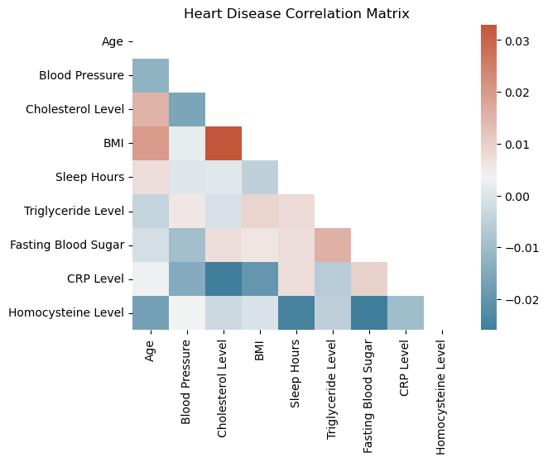

The colors on the chart are slightly misleading because they only show the relative scale of the correlations. The right bar has the true correlation scores. There, the maximum positive correlation is .03, and the maximum negative correlation is .02. Weak correlation scores in most datasets are between .1 and .3. Every single pair of variables in the data has a value under that threshold. The goal of PCA is to remove the correlation effect in multiple variables by reducing highly correlated features. However, with a dataset this free of any correlation effect, PCA struggles to meaningfully lower the dimensions because it doesn’t have obvious candidates to combine. Therefore, it is difficult to say if any insights gained from the K-Means process are trustworthy. The three PCs discussed could indicate distinct groups of people that fit certain risk profile areas, but the lack of information left much to be desired. The clearest observation gained from these exercises is that this dataset would benefit more from a different type of clustering or unsupervised analysis due to its even distribution of data and lack of defined groups.

## AGGLOMERATIVE hierarchical CLUSTERING

Hierarchical Clustering creates clusters in a tree-like structure where more similar points are closer together. Agglomerative means that the algorithm starts with every point as its own cluster. The distance of every pair of points in the data is measured, and the pair with the shortest distance is made a cluster. This process is repeated until only one cluster remains. Here is a dendrogram for a sample of 100 points in the pre-PCA data.

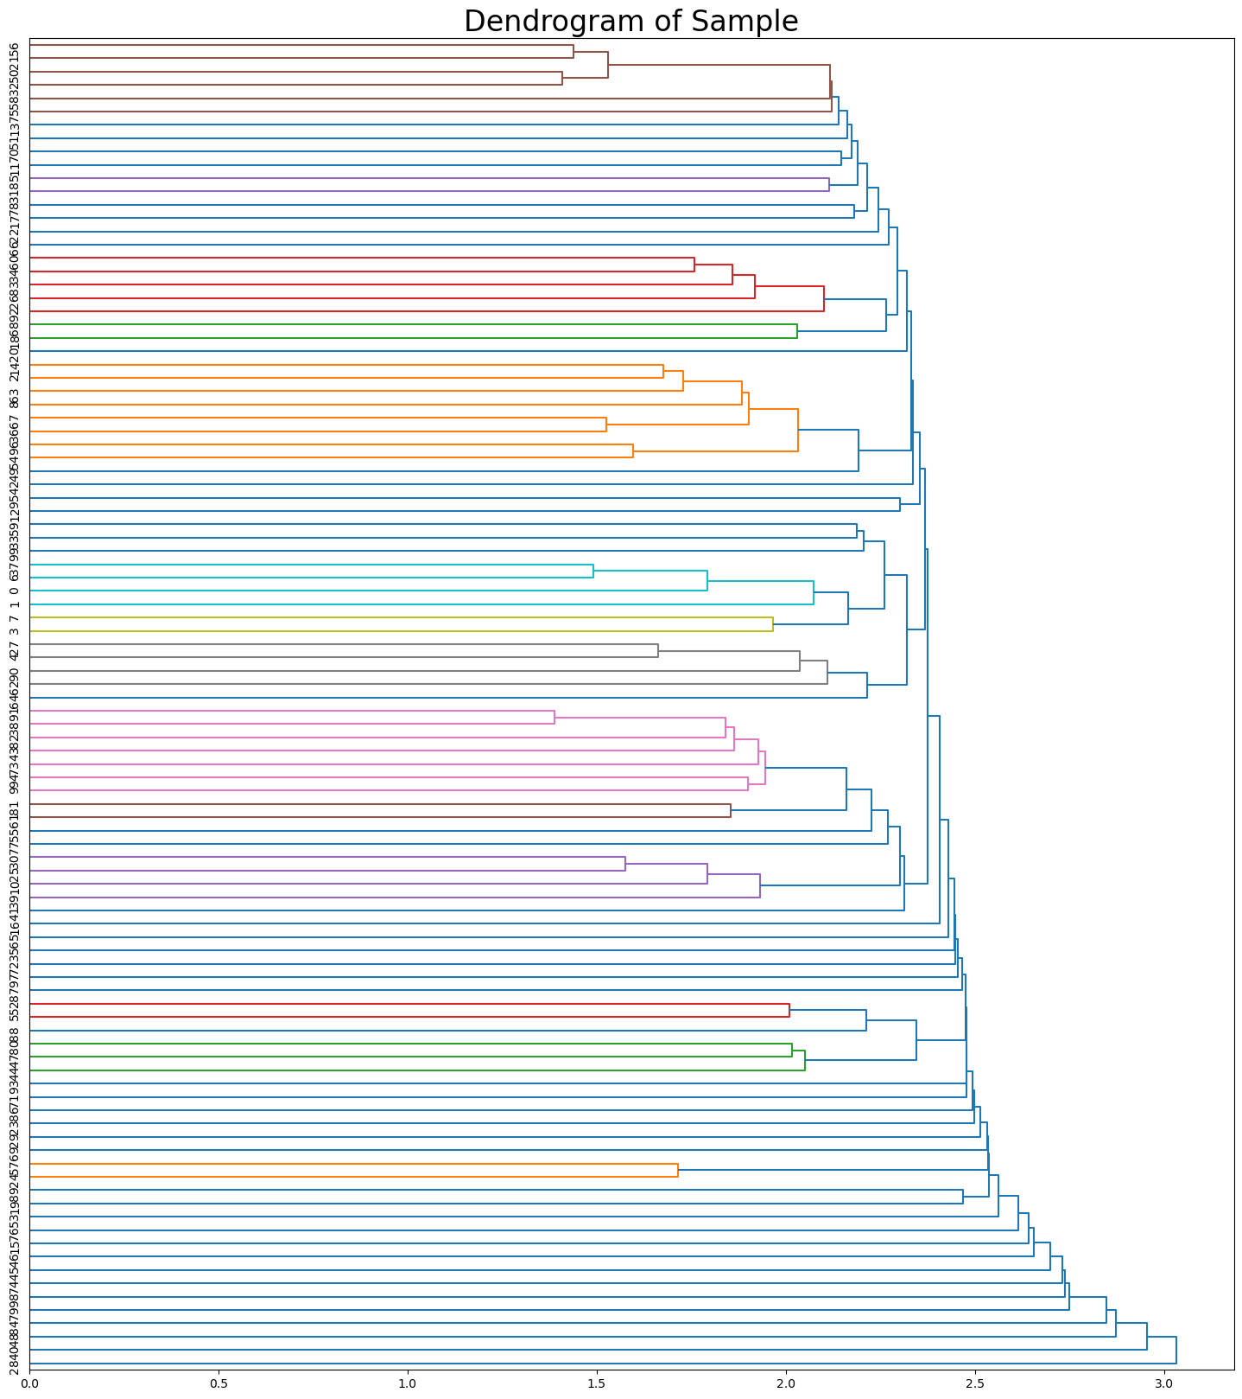

A sample of the original data was used because there were too many data points for a dendrogram; however, analysis was performed on the entire dataset. The data is so evenly separated that the clustering struggles to get meaningful results. Even though it’s only a sample, the graph above illustrates this issue. All the initial merges appear high up in the chart, then they sharply accelerate at the end. This trend suggests that the largest gaps typically occur during the initial merge when creating the clusters. This would not be the case if there were defined blobs of data, as they would merge lower in the graph and then connect to others higher up with longer distances. This data is the opposite. There is insufficient separation, and the only reason for the separation on the chart above is due to its sample size.

Comparing the K-Means and Agglomerative Hierarchical Clustering analyses reveals that both methods have limitations when applied to specific datasets. K-Means and AHC (using Ward’s linkage method) assume that the clusters are circular or spherical, and the dataset lacks those separations. The biomarker data is more continuous, following a normal distribution curve, rather than clustering in distinct areas. Lacking the inherent structure assumed by these methods, the results are a mixed data of inconsistent and uninformative pieces. Some clusters form, but it is difficult to say what those represent. Is it a real group of patients of similar types emerging from the data? Or is it simply splitting the data arbitrarily at a random point because the algorithm doesn’t know what to do? A different form of unsupervised learning, better suited for smooth data, would be a more effective approach to confirm this clustering insight or discover more.

Looking at the confusion matrices for all three clusterings—K-Means without PCA, K-Means with PCA, and AHC—the patterns are the same. The value counts for the label of the original dataset are 5632 No’s and 1435 Yes’s. Each of the clustering methods overpredicted the number of Yes’s and underpredicted the number of No’s.

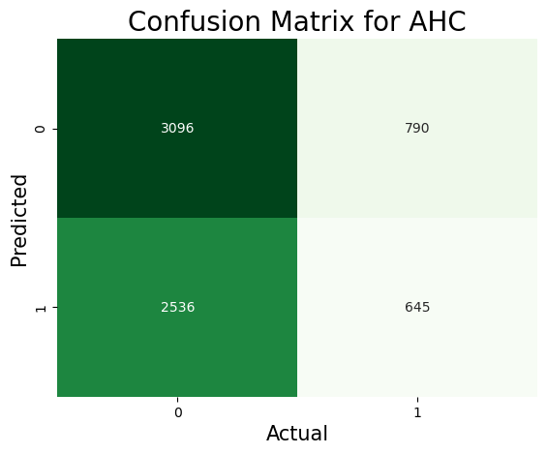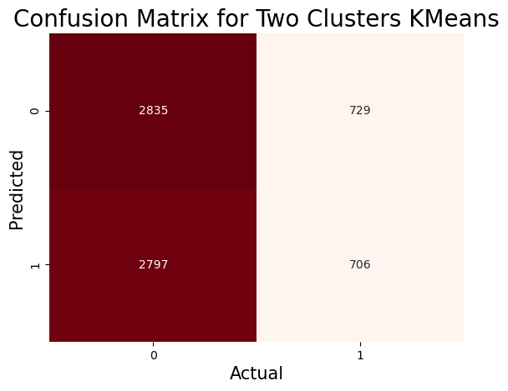

When given the task of dividing a dataset into two groups, a clustering algorithm will always attempt to create groups of equal size. However, with the imbalance of the labels in the dataset being so prominent, there was always going to be a disconnect between the two results. Therefore, the clusters and labels do not match well.

# LINEAR REGRESSION

Linear regression utilizes certain variables from the data to model a linear function and predict the target feature of the data. It is a parametric model because it assumes a linear and fixed relationship between the dependent and independent variables. To that end, only continuous, quantitative values can be used in the analysis. Therefore, this section will focus on the health biometric results for all the patients. This includes measures such as cholesterol, Fasting Blood Sugar, and CRP Level as independent variables, and the dependent variable will be blood pressure. Blood pressure was chosen as it is the most significant indicator of health disease risk in a single metric. Hypertension has been called the silent killer as it can go unnoticed or uncared for years without issues, only to end in the devastation of a heart attack.

This regression model aims to identify the factors that contribute most to high blood pressure. It’s already well known that high blood pressure is a strong indicator of heart disease. Still, forming a regression equation with these features can illuminate which reading has the most significant effect on blood pressure, revealing what factors are best to address first with a person at risk.

Here is the cleaned dataset for this section. The independent variables will be Cholesterol, Triglyceride Level, Fasting Blood Sugar, CRP Level, and Homocysteine Level. The dependent variable will be Blood Pressure.

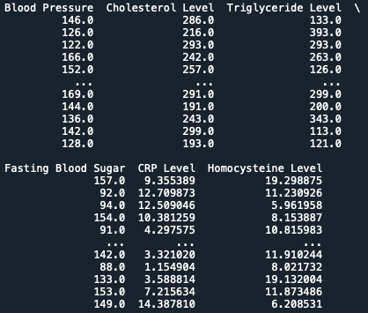

However, the p-values for each of these variables should be checked before they are entered into the linear regression algorithm. The p-value indicates the likelihood that the features do not affect the dependent variable. A low p-value (usually below .05) means that the feature is significant, while a high p-value indicates that the feature might not be adding to the effect at all.

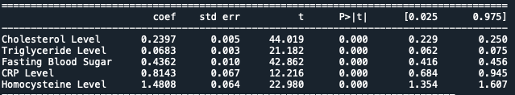

This is the result of running a model summary on the entire dataset using the statsmodels API for Python. The p-values are in the P>|t| column in the table. All the p-values are 0.000, which is a good sign that all of the features are important in the model, and there are other measures like the high T-scores for each feature that re which reinforces this idea.

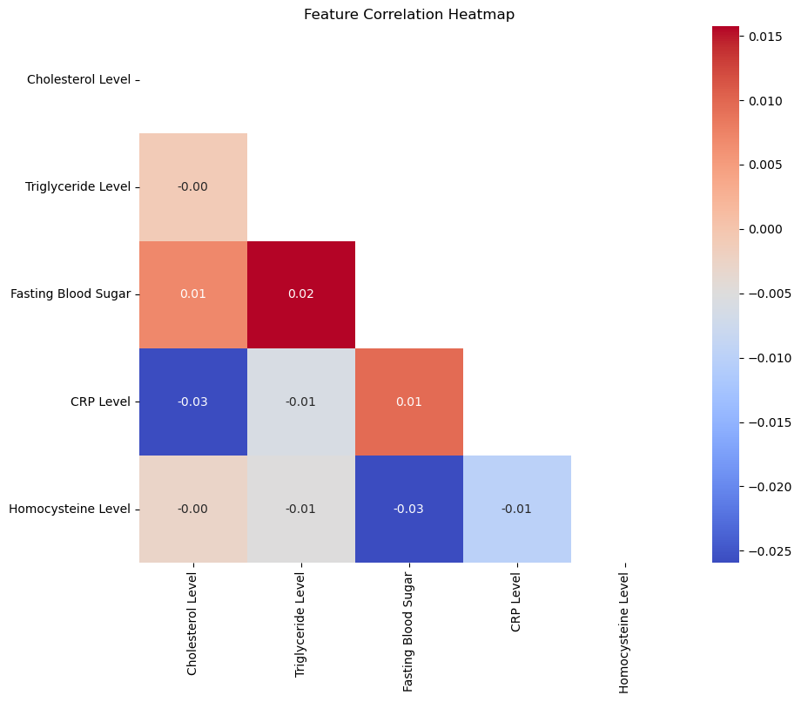

This heatmap shows that the pairwise relationship between the features is also very low. This indicates that each variable has an independent effect on the model.

After running the Linear Regression algorithm, this is the equation that the model presents:

Equation: $Y= -.008x_1+.002x_2+.001x_3-.069x_4+.033x_5+151.70$

Each X maps to one of the features from the dataset. The coefficients tell how much the dependent variable changes when the independent variable moves one unit. For example, if Cholesterol   
If the level were to rise one unit, this model predicts that the patients’ blood pressure would drop by .8 percent if all other variables were constant. If a new patient were to come into the hospital and receive all these readings, the measurements could be plugged into the model, and an estimate of their blood pressure would be the result. However, this equation is useless. All the coefficients are so small that they have little impact on the predicted variable. This model took the average of all the blood pressures, used that as the intercept, and drew a straight line through the data. There’s no linear relationship because the slope of the line is essentially zero. There’s little to gain from this regression equation because its value doesn’t change even as the underlying features expand. Here is a representation using the two variables that have the most significant coefficients: CRP Level and homocysteine Level

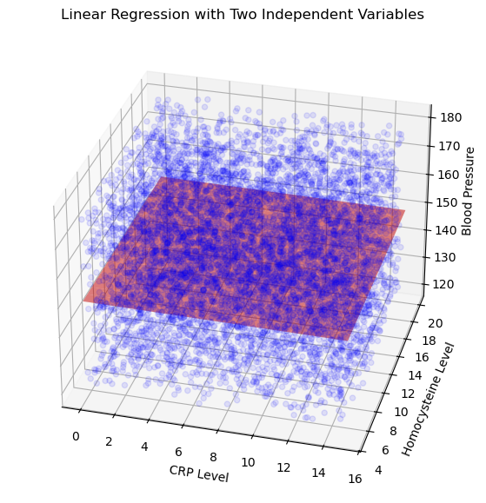

The regression plane is visible from this angle, but note how it changes when the elevation shifts.

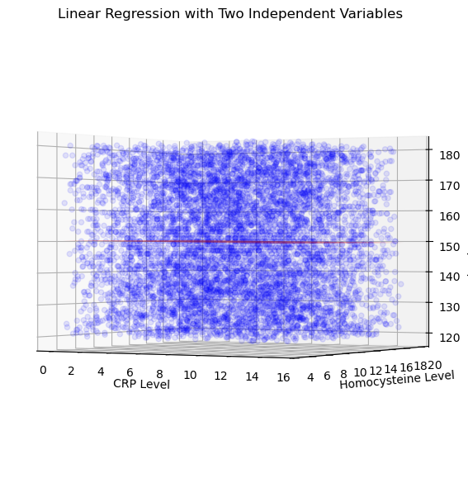

The regression line is almost exactly at the mean of blood pressure, meaning the linear model is useless for analysis because it gives no insights into the data. Another example is the coefficient of determination (R-squared), which initially appeared to be very high. Now, after running the model, it has a value of 0.0008994068296814817. A value of 0 on R-squared indicates that the mean value is provided every time, which is precisely what this model does: it simply provides the mean of the blood pressure feature for every entry.

These results demonstrate that a linear regression model is not suitable for this data. Even though all of the variables used were quantitative values, there is too much variance and randomness in the data to obtain a reasonable linear function.

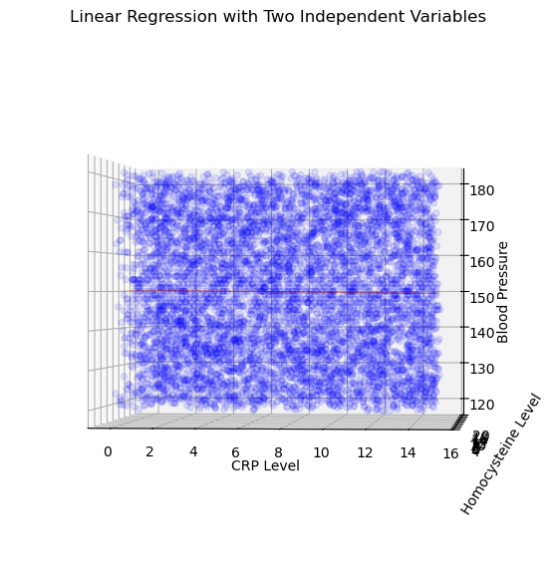

Looking at his plot, the data is again too evenly spread to put a plane through it that would fit the data well. That is why the linear model struggles to find any pattern to attach itself to in this data type.

# LOGISTIC REGRESSION

Since the biometric markers produced underwhelming results for the linear regression, the logistical regression analysis will take a different approach. This section will focus on the other variables in the original data frame, including some of the qualitative variables that have not been used until now. Most qualitative variables are already in binary form, either yes or no. These can be easily converted into numerical values using one-hot encoding. Since these only have two options, one-hot encoding will convert them into a single column where a one represents 'Yes' and a zero represents 'No'.

Now, the columns that are broken down into Low, Medium, and High are trickier. One-hot encoding could be used; however, with three options now, it would result in two columns for each feature encoded, thereby increasing the data frame's dimensionality. Instead, ordinal encoding will be used. Low, Medium, and High have an instinct hierarchy, so it is possible to keep that relationship with numbers. Low will be one, Medium will be two, and High will be three.

Once that encoding is done, the final variables for the analysis will be chosen. Lifestyle choices are the theme of this model, so all the variables will reflect patients’ habits rather than biometric measures. To that end, the features selected for this analysis are Age, Exercise Habits, Alcohol Consumption, Stress Level, Sleep Hours, Sugar Consumption, Smoking, Family Heart Disease, and Diabetes.

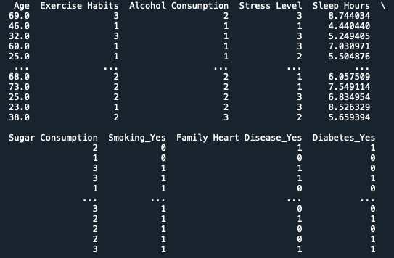

Now, using this many qualitative variables may lead to inaccurate results due to the limited information available. However, seeing how all the other methods have yielded little usable insight, it’s worth the risk to try something completely different and view the results.

Another concern is that the labels in the dataset are not well-balanced.

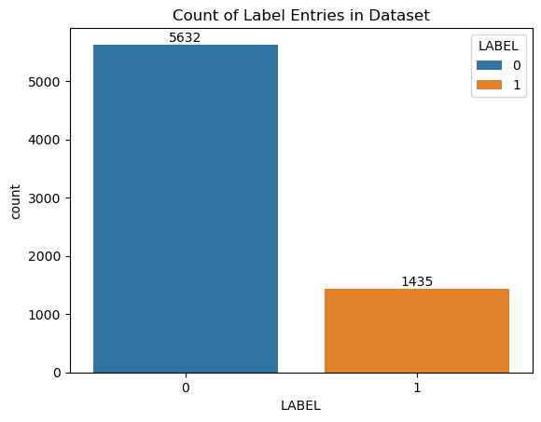

Logistic regression doesn’t require that labels be balanced, but if that is mishandled, it could lead to unexpected results. Therefore, under-sampling will be used to balance the number of entries for each label.

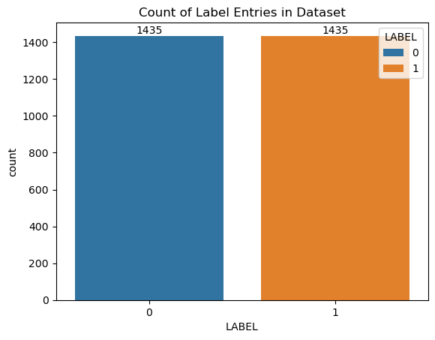

The data is now finally ready for the logistical regression algorithm.

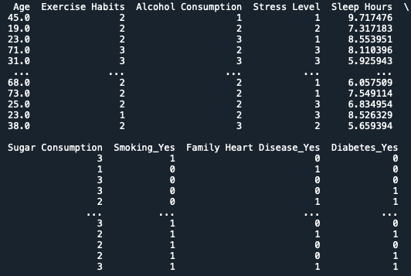

Hopefully, this model will illuminate what lifestyle factors play the most significant role in the development of heart disease. For example, if a 'yes' on the smoking feature raises the probability of heart disease prediction in the model by a significant factor, this would be a sign that smoking has a significant impact on the model's outcome, and it suggests that all patients with a 'yes' value should consider stopping.

Running the model on the training and test data yields the following linear equation. The coefficients are rounded to two decimal places. This is a linear equation without the sigmoid function.

$$y=0*age-.06*Exercise Habits+.02*Alcohol Consumption+$$

$$0*Stress Level+.01*Sleep Hours+.04*Sugar Consumption+$$

$$.13*Smoking+.1*Family Heart Disease-.06*Diabetes-.06$$

There is a great deal to unpack in this equation. Take an example of the equation in action. To highlight some of the problems with the equation, a new datapoint will be given the values that maximize each feature.

$$0*80-.06*1+.02*1+0*3+.01*10+.04*3+.13*1+.1*1-.06*0- .06= .35$$

This new datapoint was constructed to give the maximum value that the equation could realistically deliver, which is only .35. Putting this value into the sigmoid function illustrates how low that number is compared to other Logistic Regression models.

$$S(.35)=1/(1+ e^(-.35) )=.59..s$$

The result can be considered a percentage, allowing the model to achieve the maximum certainty rate. It is not a high number and does not indicate a great deal of confidence in the results. Typically, the goal is to have a model where the upper bound of the sigmoid equation is close to 1 and the lower bound is close to 0. These results are far from that and highlight that the model's predictive power is lacking.

However, it is interesting to notice that the two most significant factors that elevate the risk of heart disease are smoking and Family Heart Disease. Even with the underwhelming results, the fact that these are the largest risk increasers could be a sign of their importance in the real world.

The model will be used to predict the test set and checked against the labels.

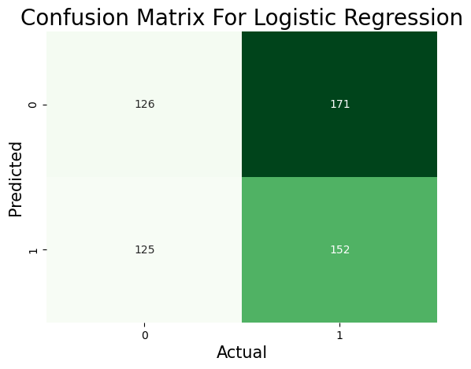

As shown, the model does not perform well in generalizing to the data, as the prediction results for the test set are below 50%.

$$(True Postives+True Negatives)/(Total Predctions)=178/574=.31=31\%$$

The model performs even worse than random chance, making it a poor predictor of heart disease. Why that is has a few different answers. The dataset used only lifestyle choices, and while those certainly can factor into heart disease, there is no direct link between them and heart disease. Poor lifestyle choices for some can lead to disease, but others with the same decisions can live their entire lives with no problems. There are nebulous factors, such as genetics, which are not fully understood yet but play a significant role in conditions like heart disease. That is why, even in this bad model, one of the most critical factors that affects the outcome is a family history of heart disease.

In conclusion, the nature of the data does not appear conducive to regression modelling. The attempt to use the qualitative variables instead of the quantitative ones did not yield any concrete results. It resulted in a model that was worse than chance. Standardizing the data in some way would have made a difference, but it is unlikely to have had a significant impact.

# DECISION TREES CLASSIFICATION

Decision Trees are a powerful supervised learning technique that has the added benefit of handling non-linear relationships. Unlike the two previous methods used, Decision Trees are not parametric, so they don’t have the limitation of fitting a linear model. This difference could be a game-changer for the analysis, as the other machine learning algorithms have been underwhelming. Continuing the analysis from before, the dataset will be split into two. One will include all the quantitative/biomarker variables in the data (e.g., Heart Rate, Sleep Hours, and Homocysteine Level), while the other will consist of all the qualitative/lifestyle variables (e.g., Family History of Heart Disease, Smoking, and Stress Level). These two datasets will produce vastly different trees, which hopefully will reveal some of the hidden patterns in the data. Both will start from the same cleaned dataset used previously.

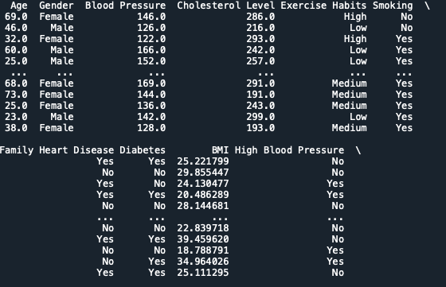

QUANTITATIVE TREE

Before preparation can begin, the dataset's imbalance must be addressed. As stated, there is an imbalance in the label numbers in the dataset, with the “No” rows in the heart disease status target variable outnumbering the “Yes” rows. To combat this imbalance, under-sampling will be used. The dataset is now balanced in its label distribution and is ready for analysis.

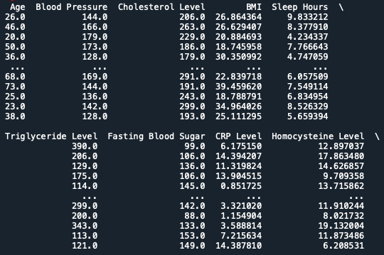

After removing all non-numeric columns, the data consists entirely of quantitative and continuous values. However, an interesting point is that the label of the data can remain qualitative in Decision Trees.

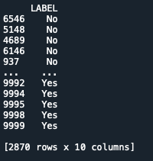

The data is ready for analysis. However, other aspects of the Decision Tree model must be addressed. If the algorithm were allowed to run unchecked and unguided, the resulting tree would be the following.

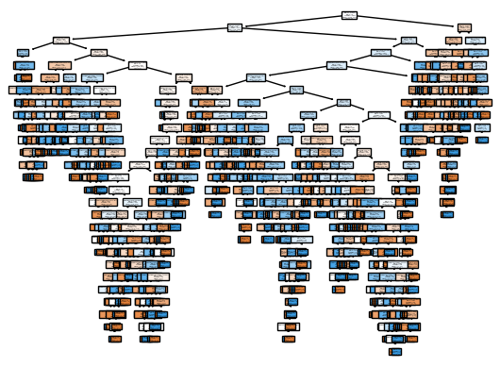

This unwieldy monstrosity is too complex, deep, and confusing to gain any insights into it. It almost certainly is overfitted to the data. To combat this chaos, there is a parameter that we can utilize to penalize the tree from becoming too complex. This process is called pruning. The optimal value of alpha can be determined by creating models with various alpha values and plotting the results.

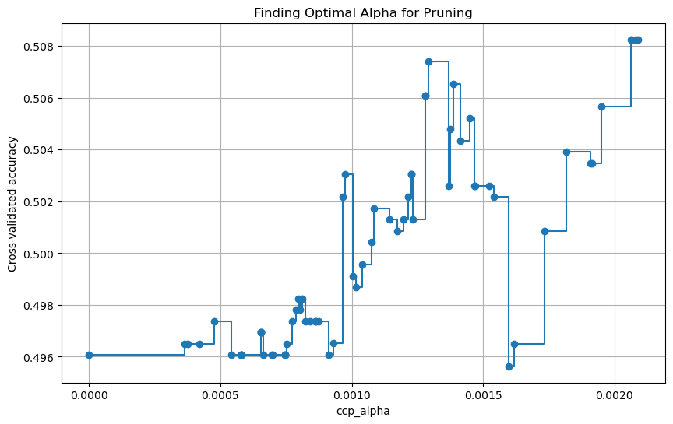

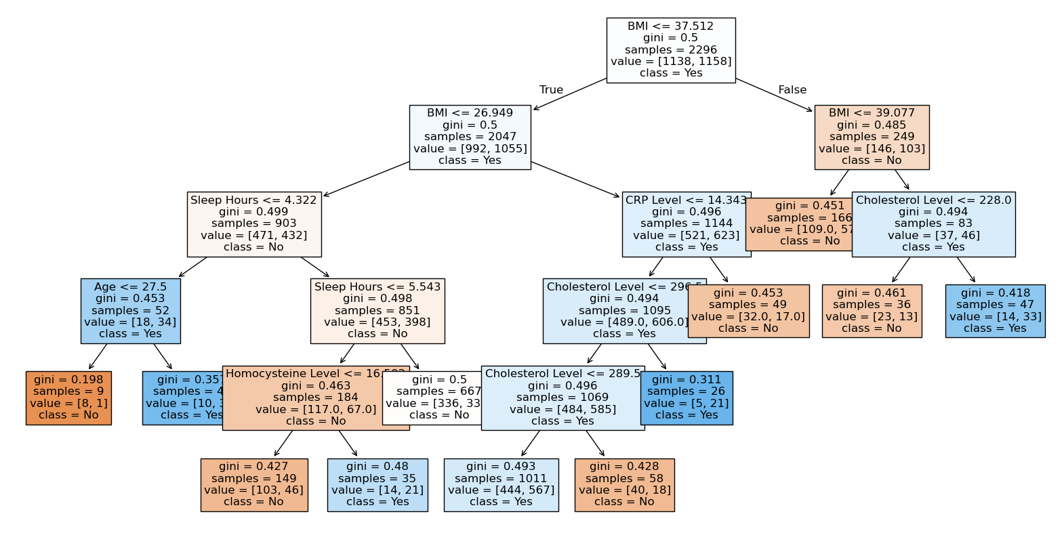As shown, the optimal alpha value for the tree is approximately 0.002. However, the max accuracy score is less than 51%, while the lowest alphas are below random chance percentages. This could be a sign that the decision tree algorithm is struggling to find meaningful patterns in the data.

Examining the tree, it is clear why the original tree was so big. Most of the leaf nodes of this tree still have Gini values close to .5, essentially meaning that most of the classifications from the tree are only slightly better than 50/50 and most likely are worse. However, there are a few leaf nodes with lower Gini’s that are of interest, especially in the far left of the tree. Going left on a tree means that the condition is proper, so following the top of the tree, there are patients with BMIs under 37.512, BMIs under 26.949, and sleep less than 4.332 hours a night. The next node is whether the person is under 27.5, as it’s a split parameter. The fascinating result is that if the patients were under 27.5, they are classified as a “No” with reasonable certainty, but if they are over 27.5, they are classified as a “Yes”. This dichotomy could reflect a subset of at-risk patients who have normal BMIs, usually a positive factor in heart disease, but are so chronically underslept that they develop heart conditions. The rest of the nodes are difficult to read, as their Gini values are so close to one-half that they appear to be inaccurate.

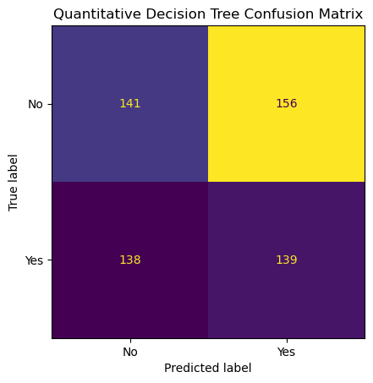

The confusion matrix confirms these fears as the model’s accuracy is below 50%.

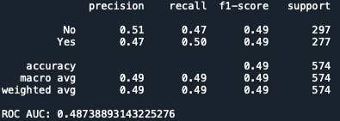

Examining the classification report and area under the curve confirms that our decision tree model performs worse than randomly selecting “Yes” and “No”.

As a test to see if the pruning alphas were the cause of the poor performance, the predictions on the test data were redone using the unaltered deep trees.

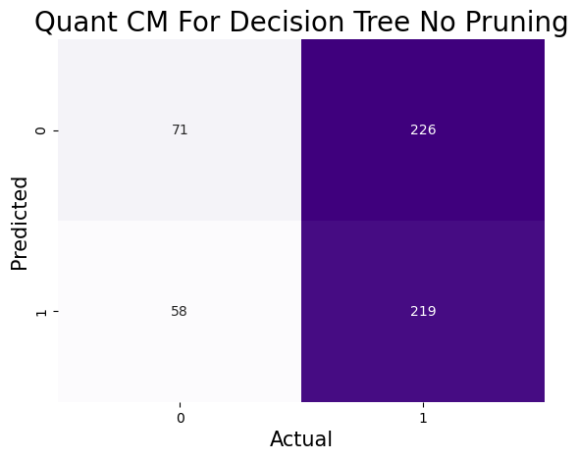

Interestingly, the quantitative unpruned decision tree scored better than the pruned tree in the weighted average, but as shown above, it’s not a significant improvement.

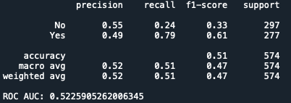

The new tree overselects “Yes”, so the recall and f1-score are high for that classification only because there are so many “Yes” answers. “No,” on the other hand, has high precision but low recall and F1-score, which means that even though the model vastly underselects “No,” it is still only 55% effective at predicting them correctly. Overall, this tree is slightly better than the pruned one, but not by much.

Qualitative Tree

Although the quantitative tree did not work as well as hoped, there is still another tree to make. For this qualitative tree, the categorical variables that we previously discarded will be reintroduced and encoded into integer values using one-hot and ordinal encoding.

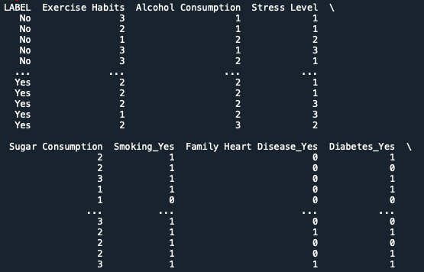

Again, the best value of alpha is calculated.

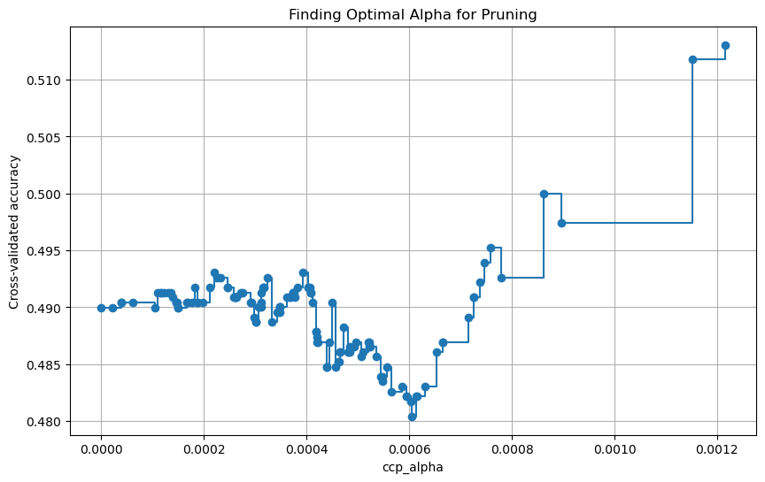

Putting that value into the algorithm creates the following tree.

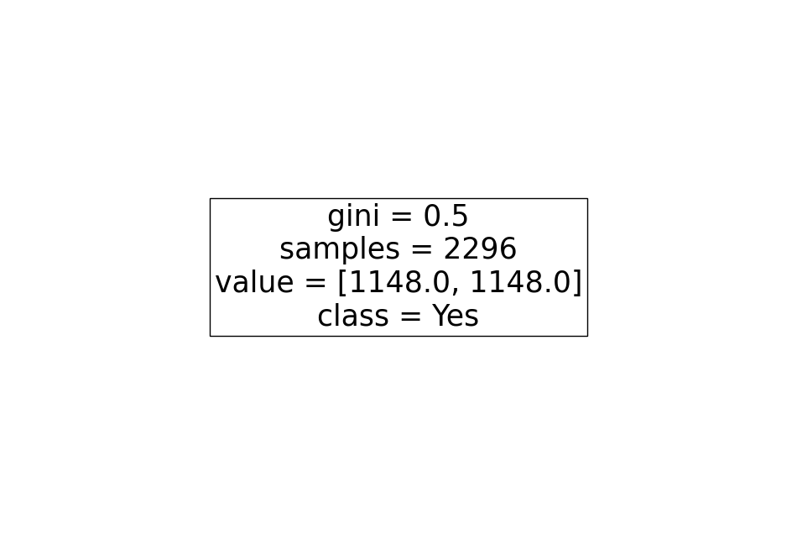

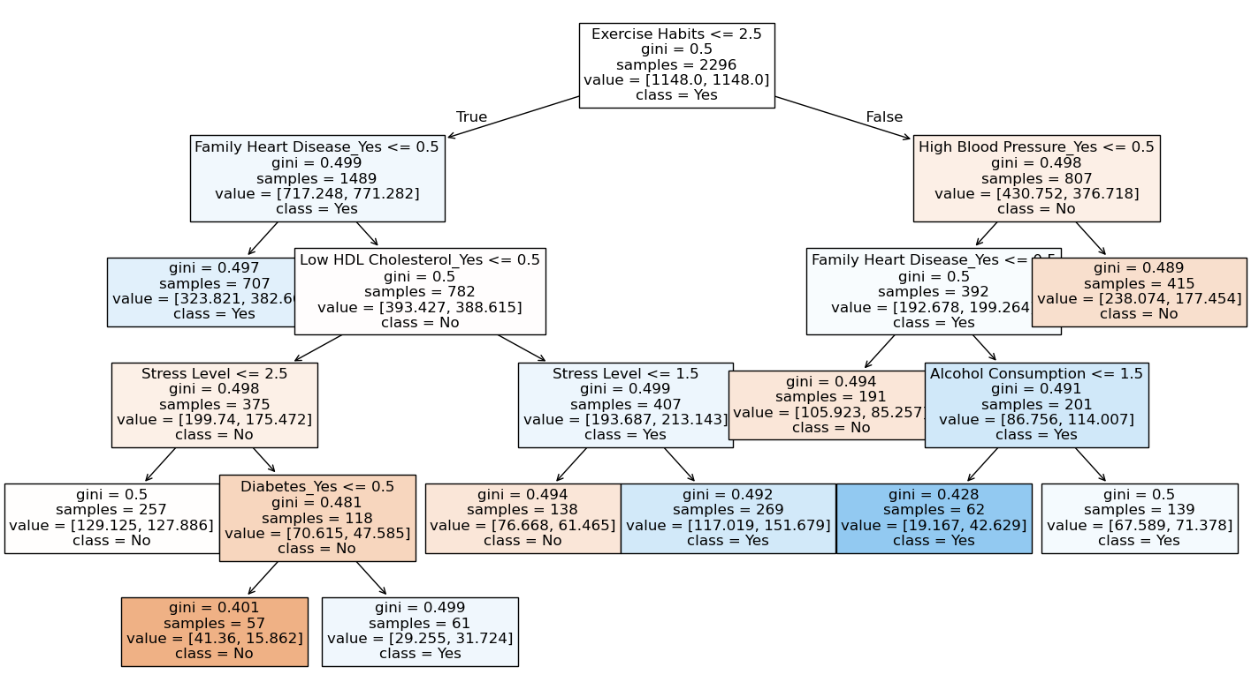Yes, that is the whole tree. Our alpha value has pruned so much of the tree off that only the base is left. But why did the graph say that this was the best value of alpha if it’s just the root node? It’s saying that because every other alpha value that allowed splits was worse than just taking the initial split of the data. To get an actual tree, the alpha value was lowered slightly to enable the branches to appear.

This is better in terms of the visuals, but the actual model is not great. All the leaf nodes have Gini values around .5, and this time, there aren’t even a few interesting ones to gain insights from. The Confusion matrix for this model illustrates this clearly.

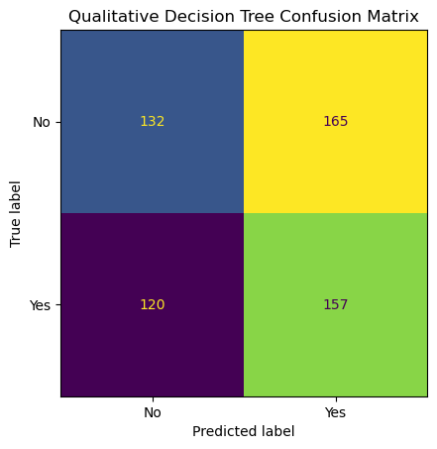

Additionally, the following are the accuracy measurements for the model.

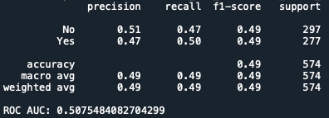

Surprisingly, the area under the curve is better for this model than the quantitative one. However, that is probably because this model is picking at random, whereas the last model had a few actual patterns that it attempted to utilize, which ultimately proved incorrect.

Rechecking the data with the unpruned qualitative tree yields the following results.

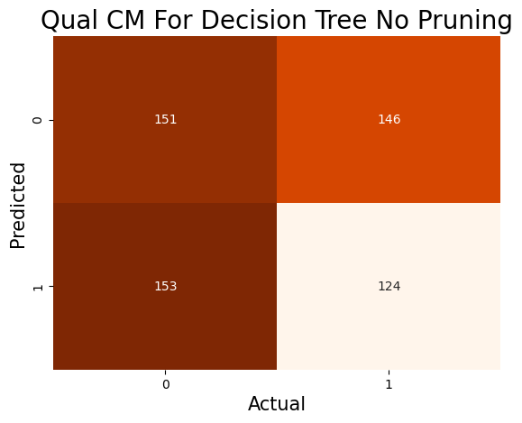

This time, the unpruned tree performs worse than the pruned counterpart, although the differences are slight.

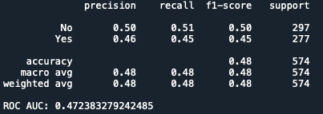

Conclusions

It is becoming increasingly frustrating that none of the machine learning methods appear to be able to handle this type of data effectively. It is becoming increasingly clear that more advanced methods should be used to combat this inscrutable data. The non-linear nature of Decision Trees could have been a saving grace, helping to pull some insights from the data. However, the data remains complex to parse, even with the linear limitation lifted. Neither the quantitative nor the qualitative trees differed significantly from random chance. The trees should have been allowed more depth, as these charts were created to be paper-friendly; however, overfitting becomes a significant concern.

Additionally, a tree that combines both quantitative and qualitative variables may yield better results. However, using a single Decision Tree for analysis is challenging due to its nature. There are an infinite number of tree possibilities, and no algorithm, no matter how well defined, can ensure that the final tree is the best one. For this data, especially, using something like Random Forest would be a good alternative, as the ensemble of trees used would get rid of much of the error and smooth out the uncertainty that persists with only a single tree.

**naïve BAYES**

The following method is Naïve Bayes analysis: A series of algorithms that utilize Bayes’ Theorem to make predictions.

$$Bayes' Theorem:P(A│B)= (P\left(B \right| A)*P(A))/P(B)$$

The two methods used in this analysis predict the classification of a new datapoint based on continuous quantitative values, and Categorical Naïve Bayes, which uses the probabilities of categorical values compared to their appearances in the target value to make predictions. Both will working off the same data, as shown below.



As in the Decision Trees section, the two methods will be split by data types. Gaussian will be applied to continuous biomarkers data, and Categorical will be applied to discrete, categorical data. This study aims to identify any additional patterns in physical medical reading data or lifestyle choices that may predict the development of heart disease.

GAUSSIAN NAÏVE BAYES

To set up the data for Gaussian Naïve Bayes, only the quantitative values will be kept. Here is the prepared dataset.



Gaussian Naïve Bayes works by assuming that all the variables in the dataset are on a normal distribution curve. Using the mean and the variance of the values in the feature for each class, new datapoints are checked against their values on both curves. After all the features of the new datapoint are converted, each of the probabilities is multiplied together, and the class with the highest score gets the datapoint classified.

Hopefully, this analysis will reveal that people without heart disease can be classified because their biomarker readings have sufficiently distinct normal distributions, which naturally separate them from one another. After running the analysis on the above dataset, the following results were obtained.

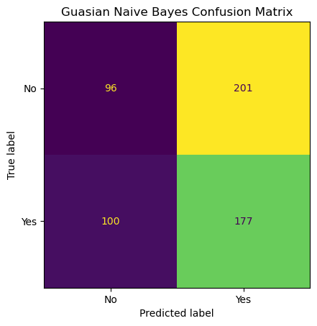

Once again, the model is no better than random chance at predicting the heart disease status of the dataset.

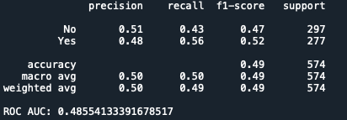

The probability of the model reveals why it has difficulty classifying the data correctly. Almost all the predictions are so close to a 50/50 split.

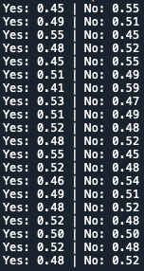

How could any model help predict if this is how close all the decisions are? The distributions of the data on the two classes are too similar. When the variances in the two classifications are not far enough apart, GNB has trouble distinguishing between the choices because the two scores for each new data point will always be close to one another. This result reinforces the early hypothesis that the biomarker data is too widely spread for sick and healthy people to obtain truly accurate predictions.



The maximum probability that the model can produce with all the test data is 59%, which is extremely low and illustrates why the model is essentially equivalent to random chance.

CATEGORICAL NAÏVE BAYES

Categorical Naïve Bayes is just what its name implies. It applies the same principles of Bayes’ Theorem, but this time using the frequencies of categorical variables in either of the target classes to predict new data. The dataset for this is provided below.



Because there is only categorical data, the idea is that through the analysis of these categorical lifestyle choices, a pattern will emerge among those with heart disease and those without.

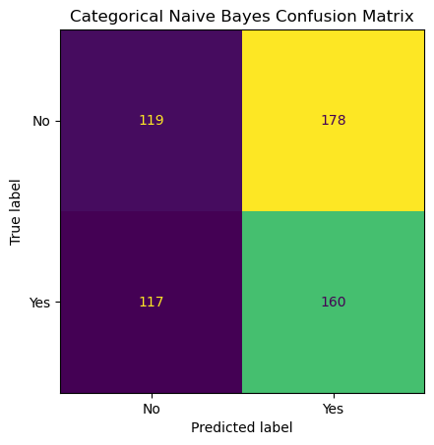

Like the Gaussian model, the categorical naïve Bayes model is not very effective at classifying data correctly.

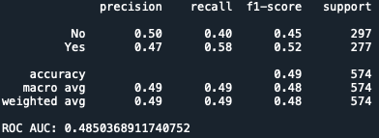

Again, the probabilities clearly state the issue. There still isn’t enough separation between the two classes to gain any insights or patterns.

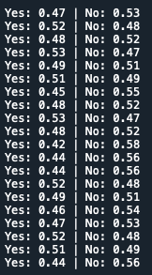

This evidence also supports the previous claims that lifestyle choices cannot be used as a measure for heart disease. They certainly are a factor, but the scale of their impact is so individualistic that it’s hard for these types of models to extract anything from the data. This result is not surprising, as it is intuitively understood that even if someone checks all the boxes for poor habits, they are not necessarily sure to get sick. And that is assuming the extremes for all the categorical features, which would be rare in reality.



In addition, the same struggle in the probabilities exists for the categorical model. Interestingly, this percentage matches that of the Gaussian model. There could be a correlation in that they both utilize the same underlying idea of Bayes’ Theorem, even with different methods.

CONCLUSIONS

Both the Gaussian and Categorical Naïve Bayes analyses were plagued with similar issues. The Bayesian methods rely on the two (or more) categories of a target variable having sufficient differences in either their normal distribution or the frequency of features to predict new data effectively. However, if the classes have remarkably similar data, which is the case for this dataset, the algorithms are not powerful enough to pick up on the subtle differences. It is not surprising that these methods were ineffective, as the nature of the dataset is contrary to what these methods excel at. Although the Categorical model is unexpectedly similar to the Gaussian one, this is likely because biomarker data appears to have more obvious patterns than a simple yes-or-no question. The fact that they are identical shows the complexity of medical studies and the human condition.

# Support Vector Machines

Support vector machine analysis involves finding the line, plane, or hyperplane that best divides the dataset into different classifications. For this report, it will be divided into two categories: “No Heart Disease” and “Yes Heart Disease”. The genius of SVMs is that if a definition cannot be discovered with the data in its dimensions, kernel functions are used to elevate the data into higher dimensions. These higher dimensions can reveal hyperplanes that divide the data well that the lower dimensions cannot. For this analysis, the quantitative biomarker data will serve as the input. Here is a picture of the cleaned data. It has also been balanced and undersampled.

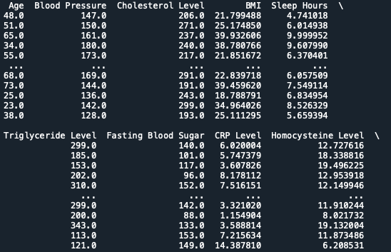

To determine which kernel function best divides the data, three different functions will be used: Polynomial, RBF, and Sigmoid. Additionally, other costs will be considered to influence the sensitivity of the models to incorrect predictions.

POLYNOMIAL

The Polynomial kernel applies a polynomial function to each of the datapoints to extend them into higher dimensions. The user has a choice in the degree (or power) to which the function will be applied. To start, the first choice will be a simple square function with a cost of 1. The cost of the function is a penalty term that reflects the extent to which the model is affected by incorrect classifications. A high cost means that a model heavily penalizes for wrong classifications when picking the best support vector, while a low cost is the opposite, with the model caring little if datapoints are wrongly classified.

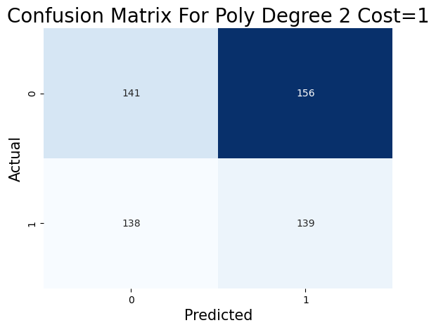

This is the most basic of the functions to run, so it is not surprising that, based on the rest of the analysis, this model struggles to separate the dataset in a meaningful way.

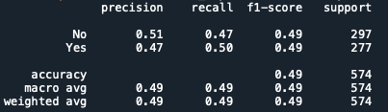

It’s essentially just as good as chance, but what happens when the cost is elevated?

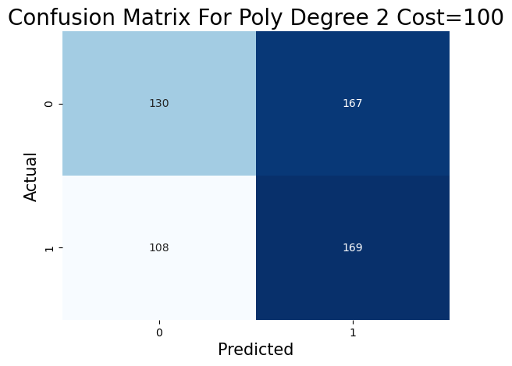

With this higher cost, the model does improve slightly in overall accuracy, but the improvement is only slight and is mainly caused by the model overemphasizing the response of “Yes”.

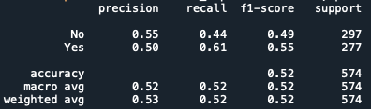

A higher cost might be better for this model with a different kernel, but the gains for the polynomial ones are slight. To be complete, the next model will have a low cost.

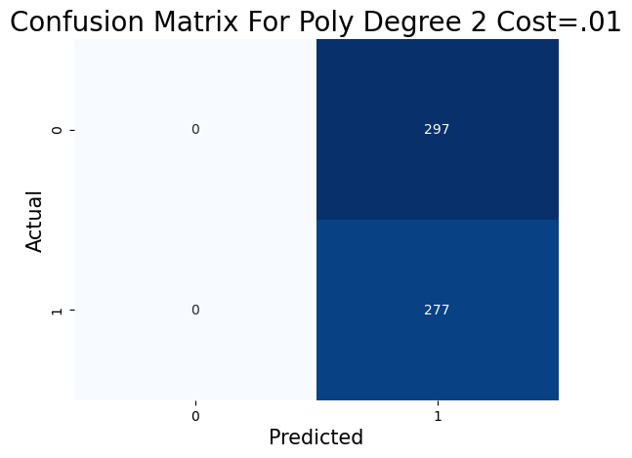

This model illustrates the power of the cost term in SVMs. With essentially no penalty for wrong classifications, the model decides to classify everything as “Yes”. This indicates that for this dataset, a higher cost is preferable; however, both a high and low cost overly favor the “Yes” class—something to keep in mind in the future.

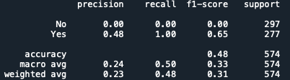

With this new understanding, it is time to move on to the next kernel in our analysis: RBF.

RBF

The RBF is like the polynomial kernel, but it uses some high-level math to represent what the transformation of the data would be in

infinite dimensions. Essentially, it is the polynomial kernel taken to its limit. Although it is less intuitive than the polynomial kernel, in practice, it yields better results for support vector machines (SVMs).

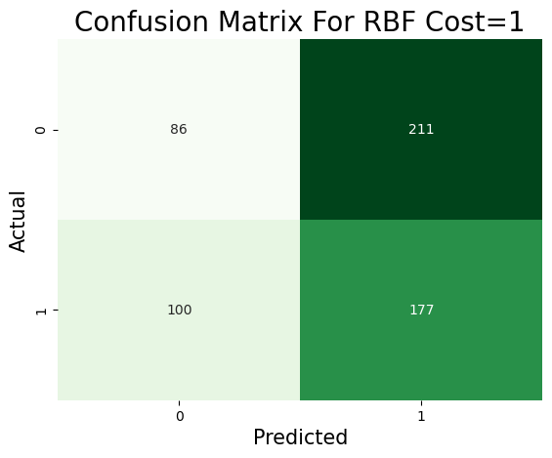

Surprisingly, keeping the cost at one, the RBF model performs worse than the two-degree polynomial results.

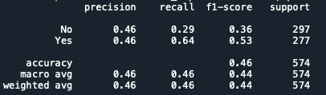

However, as was previously shown, a higher cost produced a better model. Therefore, raising the cost to 100, as before, should yield better results.

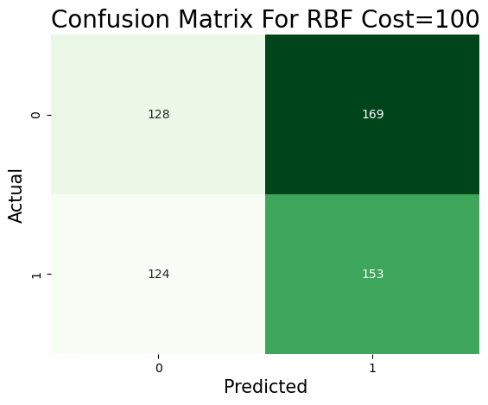

While this model is better than the lower-cost RBF, it still falls short of what one would have hoped.

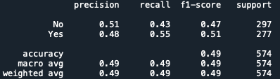

The biomarker dataset cannot be easily divided using these polynomial-like kernel methods.

SIGMOID

The Sigmoid kernel uses the tanh function to map the datapoints into higher dimensions, different from the polynomial functions previously used.

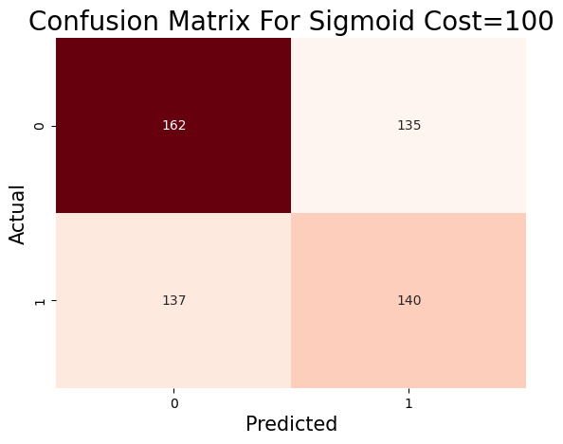

Although far from perfect, this sigmoid model is the best to fit the data by far.

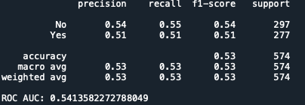

There may be something about this model that the others are missing. To test this theory, a K-fold cross-validation will be run on the model to determine if this accuracy persists.

KFolds essentially splits the training data into multiple training and testing mini-splits to ensure that the model is not overfitting to any one section of the data.

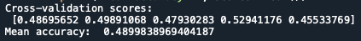

Unfortunately, the KFold breakdown is not suitable for this Sigmoid function model. Although it performed better on the testing data, the low scores on the cross-validation indicate that the higher score was most likely due to random chance rather than providing fundamental insights into the data. Additionally, the spread from the highest to the lowest accuracy is over 7%, indicating that the model is struggling to find meaningful patterns in the data. While the sigmoid function seemed promising, the cross-validation check has revealed that its better scoring is more likely an accident rather than anything insightful.

Conclusions

The cross-validation results for the sigmoid kernel SVM reveal the limitations of this approach on the heart disease dataset. With an average accuracy of only 49%, the model performs no better than random chance, which would be 50% for predicting whether someone has heart disease or not. The scores across the five different data splits ranged from 45.5% to 52.9%, demonstrating inconsistent performance that suggests the model cannot reliably identify patterns in the data. While the sigmoid kernel initially appeared promising with better results on the test data compared to the polynomial and RBF kernels, the cross-validation analysis exposed that this higher performance was likely due to random chance rather than genuine learning.

This heart disease dataset continues to stump most of the machine learning algorithms that have been tested, and support vector machines are no exception. The poor cross-validation results highlight several key limitations of SVMs that may have contributed to the disappointing performance. SVMs rely on finding clear boundaries to separate different classes of data. Still, this dataset appears to have complex, overlapping patterns that cannot be easily divided by the mathematical functions used in SVM kernels. Additionally, SVMs are highly sensitive to parameter choices, such as the cost function. Even after testing different kernel types and cost values, none were able to achieve meaningful accuracy. The 7% spread between the highest and lowest accuracy scores across folds further confirms that the model is struggling to find consistent, reliable patterns that can be applied to new data.

# ENSEMBLE CLASSIFICATION

Ensemble models utilize the methods mentioned previously in this report. Still, instead of single instances, these models combine them into a larger framework of base models that build into a collection that decides on classification through the average output of each model. For these models, since they are collections of different ones, the entire dataset will be used as before, and the categorical features will be ordinal or one-hot encoded into numeric values. Hopefully, these models, through their combined power, will be able to classify heart disease more accurately than before.

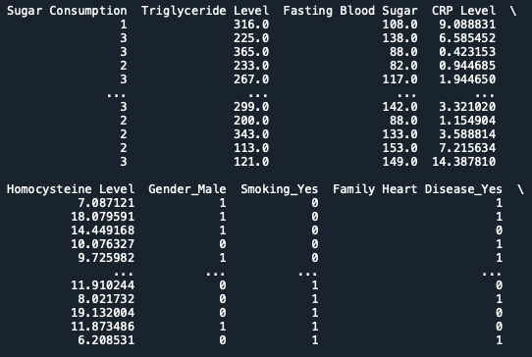

The three ensemble methods used will be Random Forest, AdaBoost, and Stacking.

Random Forest

Random Forest uses a collection of decision trees that are all averaged together to make a final prediction of the datapoint. This type of model works because there are so many trees that any overfitting or underfitting of the data is averaged out in the long run. It is a more consistent and precise choice because a single tree has a lot of variance and bias built into it. When it’s 100 trees working together, the faults of a single tree disappear into the spectrum of the others.

For the first Random Forest model, the standard out-of-the-box parameters will be used: 100 trees with no max depth.

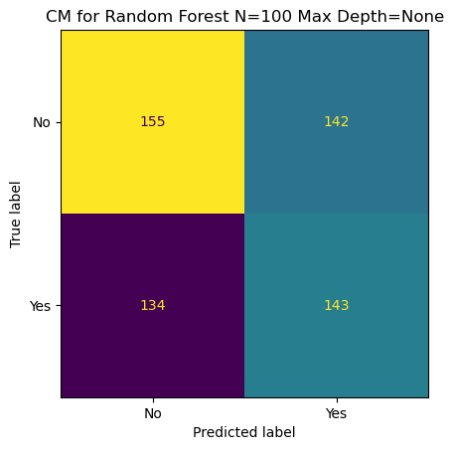

The results of this model are not ideal, but they are obtained using the default parameters of the Random Forest package. There must be a more suitable set of hyperparameters for this dataset. To find this ideal set of parameters, a Grid Search will be run, testing a range of different values for the Random Forest settings. The parameters are N_estimators, max_depth, min_samples_split, min_samples_leaf, max_features. The Grid Search will check the accuracy of all these different combinations and report back the optimal set of parameters.

After running the search, these are the parameters that were considered the best: n_estimators: 100, min_samples_split: 5, min_samples_leaf: 4, max_features: .03, and max_depth: 20.

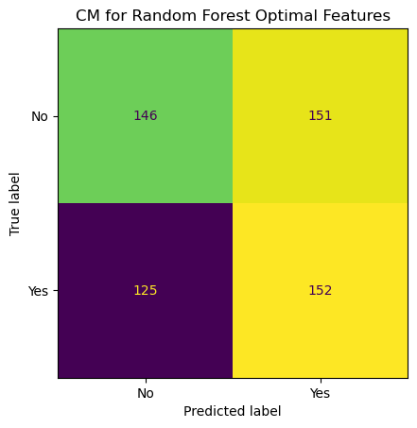

However, even with these fine-tuned hyperparameters, the model still performs poorly.

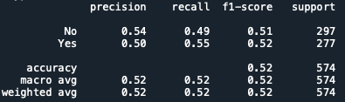

It does slightly better than chance, but not by much. Examining the feature importance list reveals a clear preference for the biomarker data in this random forest model.

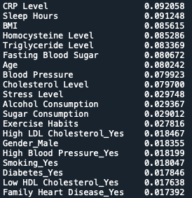

There is a clear divide in the features from the biomarkers to the list-style choices. Cholesterol is at 7.9% as the last biomarker, and then there’s a drop to 2.9% for Stress Level. Is this because biomarkers are more critical? It’s hard to say. The answer is probably yes, but it can’t be that simple. Family Heart Disease is at the bottom of the feature importance list, yet it is common knowledge that one’s family medical history plays a significant role. Something is missing in the data that is limiting the predictive power of the Random Forest Model.

To illustrate the complexity of these models, here are some examples of the trees that are created. One of the issues with ensemble models is that the ability to explain how the model works is lost. It becomes a black box that spits out an answer, but it is hard to explain how that answer was chosen.

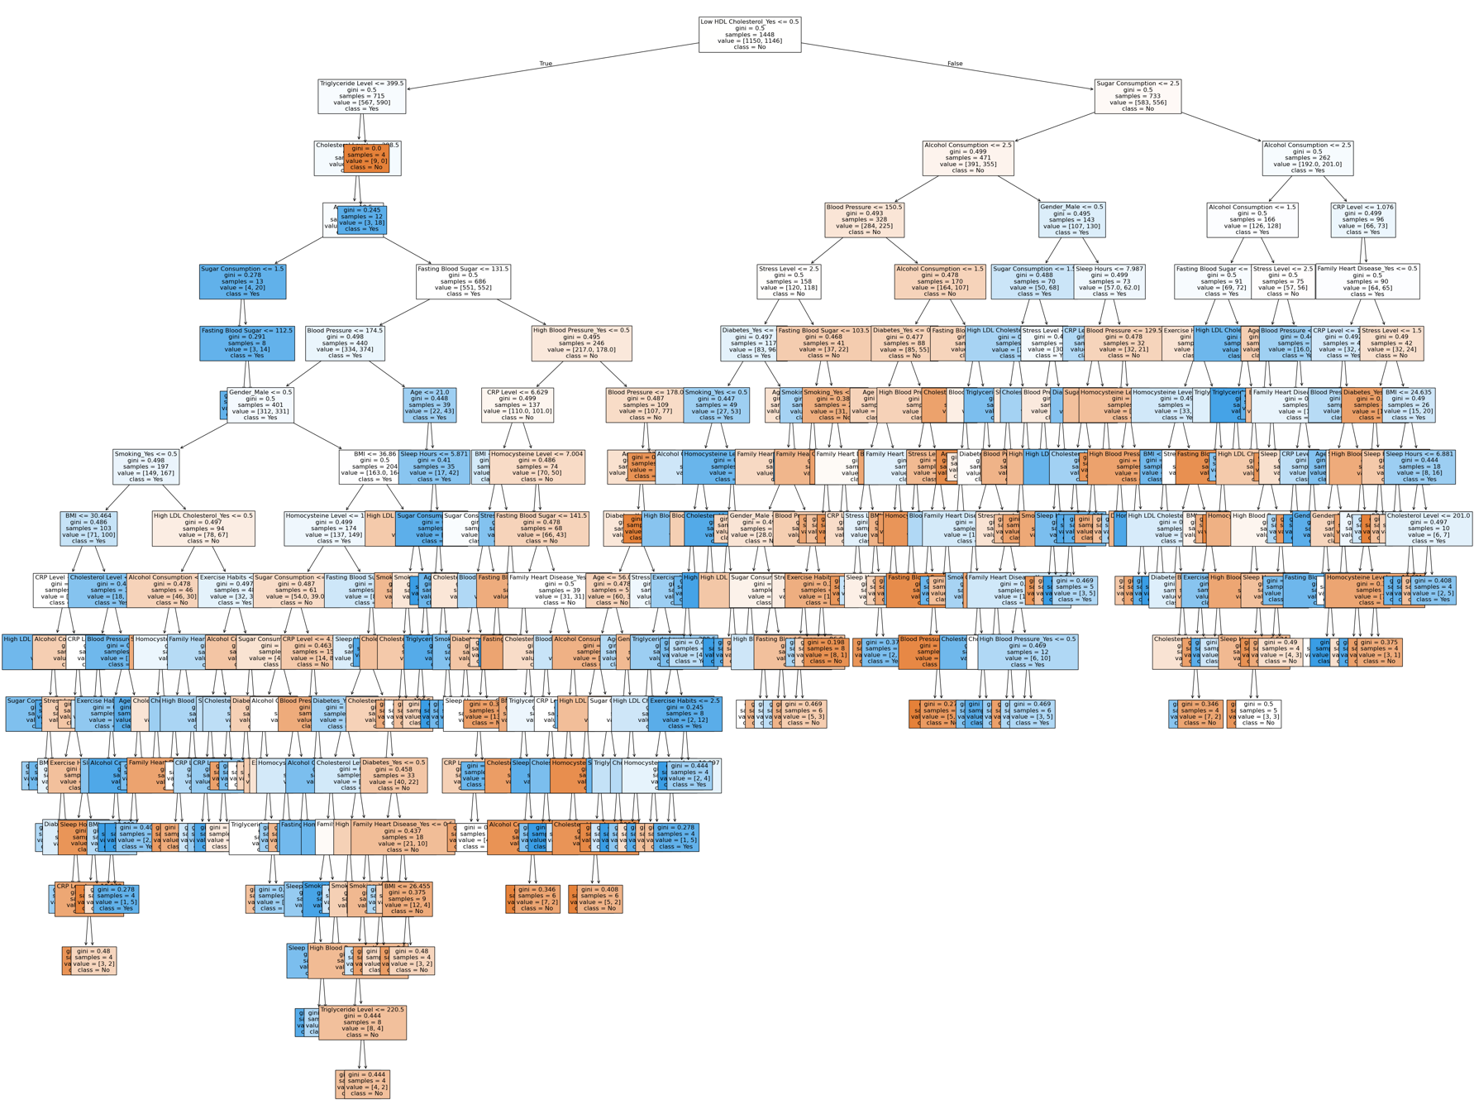

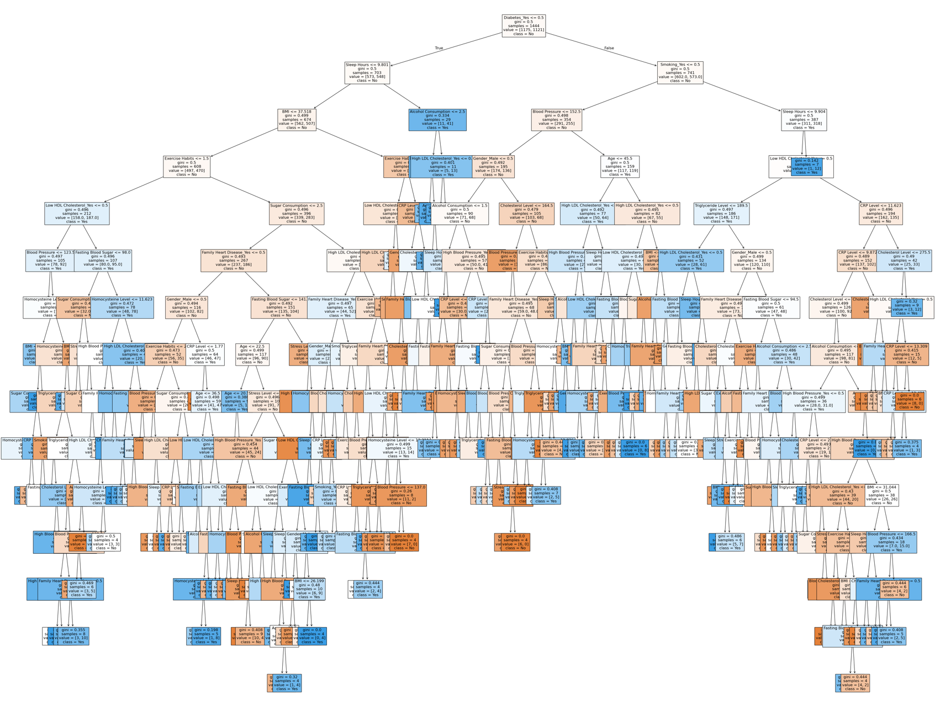

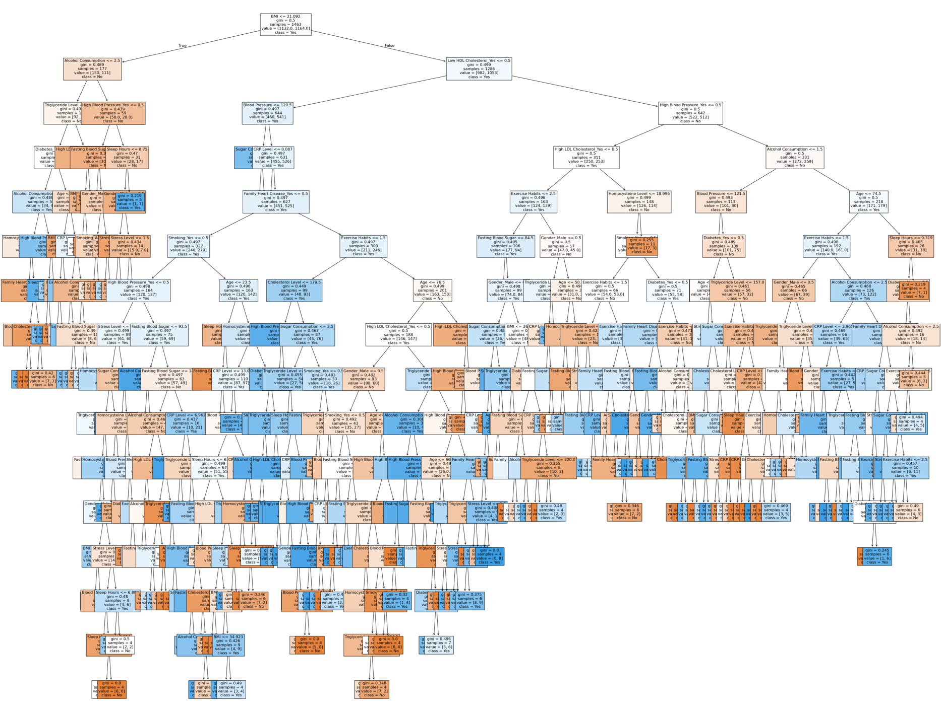

ADABOOST

AdaBoost is an ensemble method that uses weak Decision Tree learners and boosting algorithms to train multiple models in sequence, with each iteration improving on its predecessor’s errors. The dataset used will be the same as the one for Random Forest, with categorical features transformed into numeric values. Hopefully, the boosting method will be able to classify heart disease in the dataset population better than the Random Forest method. As before, the model's target is a “Yes” or “No” answer. The first instance will be the default parameters of AdaBoost.

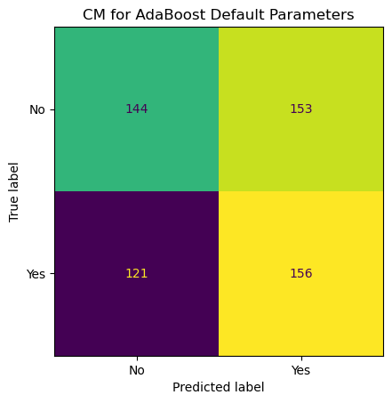

The results are not exceptional, but they represent an improvement compared to the previous models.

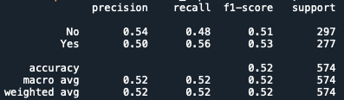

However, as before, this is just the default settings right out of the box of the sklearn library. Again, a Grid Search will be used to determine if optimal parameters can be found that improve the model's results. The parameters to tune are the number of estimators, the learning rate, and the maximum depth of the base Decision Tree.

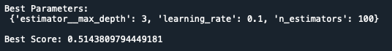

After running the check, the best hyperparameters found were Max Depth of 3, Learning Rate of .1, and Number of Estimators 100. However, the cross-validation check yielded a best score of only 51%. Nothing to write home about, but it is time to see how it fares on the test data.

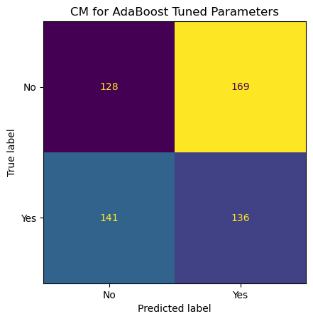

Interestingly, the model with the “tuned” parameters did worse than the default model. This shows that even these powerful ensemble methods still struggle to find patterns in the data. The Grid Search finds the best parameters for cross-validation of the training data; however, due to the lack of real information gained, these parameters are overfitted to the training data. Bringing in the test set and its poor performance proves as much. The model can’t work generally because it can’t find any usable insights.

To further illustrate this point, examine the probabilities assigned to the test set.

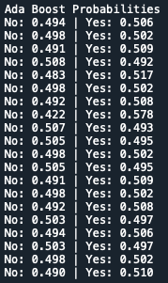

Even after all the learning that was done, most of the samples are still squarely in the 50/50 zone of the model. Each classification is just a clip of a coin. However, compared to other models done in this report, the max probabilities given for “Yes” and “No” are pretty high.



This reveals that the model is learning something about the data, but there isn’t even enough for it to generalize over the entire population. Instead, there are outliers with high certainties, but there’s no guarantee that these are even correct classifications. The classification for the datapoint with the maximum “Yes” probability is wrong. It is a “No”.

Unfortunately, both the Random Forest and AdaBoost methods failed to find any meaningful models of the data that weren’t better than random chance.

STACKING

Stacking is an ensemble method where different types of models are combined, and each is given a vote in the final classification of a datapoint. It is like Random Forest, but instead of only using Decision Trees, any model can be used. For this report, Random Forest, RBF Support Vector Machine, and AdaBoost will be used, with Logistic Regression serving as the output estimator, resulting in a final answer that is a probability. The same full dataset will be utilized for this model. The hope is that adding all these different models will even out the noise that each one individually has.

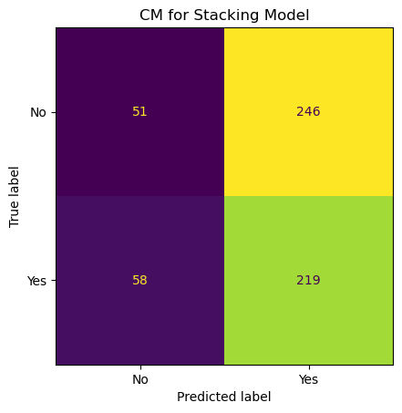

Unfortunately, that was the case, as the stacking model highly overselected “Yes” from the dataset.

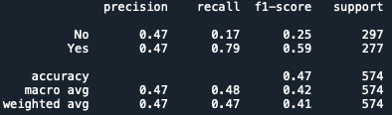

This result is not surprising, as all the models seem to favor “Yes” in their selections. Therefore, when adding them all together, the shared bias for “Yes” appears as over 80% of the total test datapoints were classified as “Yes”. In addition, the probabilities of the model demonstrate that even with three different algorithms working on the data, most datapoints are essentially a coin flip, slightly preferring “Yes” most of the time.

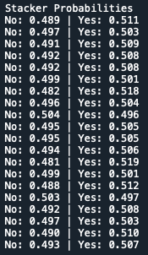

The issue with stacking is that if the models that it is using as inputs don’t have any reliable handle on the data, there’s no way adding them together will somehow yield more reasonable results. There needs to be some initial validity in the inputs for the outputs to work. However, this data has stumped all of the ensemble learning methods. Not one has been able to produce anything better than slightly above a coin flip, and even then, if further testing were to be done, those would likely regress to 50/50 as well.

# Conclusions

Unsupervised

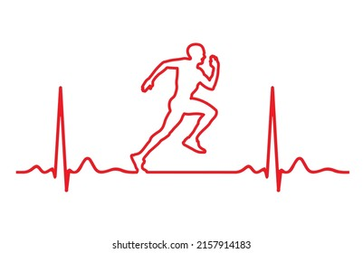Based on the unsupervised learning portion of the analysis, the first conclusion from this project is that clustering is challenging with the type of biomarker data used. The data’s continuous, smoothly distributed nature cannot be easily compartmentalized into distinct clusters, leading to seemingly random results. K-Means will take one feature of the data and perfectly divide it, while the rest are left virtually unaltered in a jumble. Agglomerative Hierarchical Clustering struggles to make sense of the clusters and puts all the points on one side of the graph, as if the whole dataset is one massive super cluster. If this analysis continues, using different unsupervised methods—ones specifically designed for working with even data—would be at the top of the list of new ideas to try. There are likely to be insights that unsupervised learning could reveal, but clustering algorithms are not the best way to discover them.

Regression

The linear and logistical regression analysis results were poor in their ability to create a predictive model. Regression models assume that the relationship of the dependent variable to the independent variable takes the form of a linear equation. Regression is called parametric—the models make assumptions about the form of the underlying function that describes the data. This method can be powerful when used with the correct data, but it has significant limitations when applied to incorrect data. Based on the lackluster regression results, it is reasonable to conclude that the lifestyle and biometric values used in this report are more effectively described using non-linear methods than linear ones. This idea makes sense intuitively. If heart disease could be diagnosed by a simple equation of a patient’s biometrics and lifestyle choices, there would be much more early detection and prevention. If a patient was edging close to the arbitrary heart disease value, doctors could take immediate action and know exactly what to treat to prevent a heart attack. No distinct line or linear combination of factors can add up to a definite diagnosis. People have different risk thresholds, genetics, and unforeseen circumstances that a regression model can’t fully encompass.

DECISION TREES AND   
NAÏVE BAYES

Despite exploring both Decision Tree and Naïve Bayes classification methods on the heart disease dataset, neither approach delivered satisfactory predictive performance. The Decision Trees, although capable of capturing non-linear patterns, either overfit the data when unpruned or become overly simplistic when pruned, resulting in poor classification accuracy. Even when the dataset was split into quantitative and qualitative subsets, the resulting models produced outcomes that were only marginally better—or in many cases worse—than random guessing. Similarly, both Gaussian and Categorical Naïve Bayes models struggled due to the lack of strong, distinguishable patterns in the data. The close overlap in feature distributions across the target classes rendered probability scores nearly indistinguishable, indicating that the assumptions required for these algorithms to perform well were not met. Overall, these results highlight the complexity and subtlety inherent in medical datasets, suggesting that more sophisticated, ensemble-based methods, such as Random Forests or Gradient Boosting, may be necessary to uncover deeper patterns and enhance predictive reliability.

SUPPORT VECTOR MACHINES

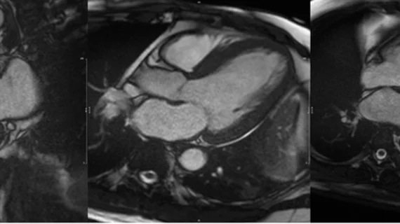The support vector machine (SVM) analysis with varying kernel functions and cost parameters revealed the limitations of this modeling approach for the current biomarker dataset. The Polynomial kernel, even when adjusted with different cost values, struggled to find meaningful separation between classes, tending to overpredict the “Yes” class regardless of tuning. The RBF kernel, despite its theoretical advantage of infinite-dimensional transformation, also failed to improve performance significantly, suggesting that the structure of the data is not conducive to separation by such functions. While the Sigmoid kernel initially appeared to outperform the others, KFold cross-validation revealed that its improved accuracy was likely due to random variation rather than robust learning. Overall, the inconsistency and weak performance across all kernels indicate that the data lacks the distinctive structure needed for SVMs to succeed, reinforcing the need to either explore alternative modeling approaches or enrich the dataset with more informative features.

MRI Scan of a Heart

ENSEMBLE METHODS

While ensemble models, such as Random Forest, AdaBoost, and Stacking, are typically powerful tools for classification tasks, their performance in this study was underwhelming. Despite extensive hyperparameter tuning, none of the models achieved accuracy significantly better than random guessing. The Random Forest model, even when fine-tuned, demonstrated limited predictive capability, favoring biomarker data but failing to capture more nuanced patterns. AdaBoost showed a slight improvement using default parameters, but hyperparameter tuning decreased its effectiveness, likely due to overfitting. Stacking, while theoretically promising due to its combination of diverse models, suffered from compounding biases across its base learners, particularly an overprediction of the "Yes" class. Ultimately, the shared weakness across all three models suggests that the underlying dataset lacks the necessary structure or informative features for successful classification, thereby limiting the potential of ensemble methods to improve the prediction of heart disease outcomes.

# ABOUT THE AUTHOR AND IMPROVEMENTS

Working on this project has been both a rewarding and challenging experience. One of the most frustrating aspects was dealing with the dataset’s noise and inconsistency. The modeling process was sometimes complicated. Still, it also underscored the level of dedication and persistence required when working with real-world data, especially in high-stakes fields such as business and medicine. It made me appreciate how much effort goes into even the simplest of insights when the data isn’t clean or clear. Looking back, I wonder if a different, less noisy dataset would have led to more reliable results. In the future, I would consider shifting the focus from predicting whether someone already has heart disease to instead predicting their risk of developing it. While this dataset included many individuals who had all the warning signs of heart disease without receiving a diagnosis, a risk-based approach would better reflect real-world applications where early intervention is critical. In practice, the goal is to prevent heart disease before it fully develops, and machine learning can play a decisive role in identifying those at risk before it’s too late.